WEB APPLICATIONS DEVELOPMENT LAB BCA-DS-354

**Manav Rachna International Institute of Research and Studies**

**School of Computer Applications**

**Department of Computer Applications**

|  |  |
| --- | --- |
| **Submitted By** | |
| **Student Name** | **Deepak** |
| **Roll No** | **23/SCA/BCA/078** |
| **Programme** | **BCA** |
| **Semester** | **Third Semester** |
| **Section/Group** | **3-B** |
| **Department** | **Computer Applications** |
| **Batch** | **2023-2026** |
|  | |
| **Submitted To** | |
| **Faculty Name** | **Miss Savita Dagar** |

|  |  |  |  |  |
| --- | --- | --- | --- | --- |
| **S.**  **No.** | **Date** | **Aim of the Experiment** | **Signature/Date** | **Grade** |
| 1 | 02-08-2024 | **Create a simple HTML page using basic tags.** |  |  |
| 2 | 09-08-2024 | **Create a web page that displays your name to the screen.** |  |  |
| 3 | 09-08-2024 | **Create a web page and show the output from 1 to 10 in**  **separate lines** |  |  |
| 4 | 16-08-2024 | **Create a web page and show the output from 1 to 10 in separate lines, each number being in different colour.** |  |  |
| 5 | 16-08-2024 | **Make a picture as a background on the web pages** |  |  |
| 6 | 23-08-2024 | **Create a web page to print a paragraph with 4-5 sentences, each**  **sentence shall have a**  **different font** |  |  |
| 7 | 23-08-2024 | **Write HTML code to print a paragraph that is description of a book, it shall include the title of the book, its author name; name and title should be**  **underlined and all adjectives shall be**  **bold and Italics** |  |  |

|  |  |  |  |  |
| --- | --- | --- | --- | --- |
| 8 | 30-08-2024 | **Write HTML code to print your name using Heading tag, every letter shall be of different heading size 9.** |  |  |

|  |  |  |  |  |
| --- | --- | --- | --- | --- |
| **9** | **30-08-2024** | **Write HTML code to print the sequence of numbers 1-20. Each number shall be in different line with number 2 next to it as subscript, an equal sign and the result.** |  |  |
| **10** | **06-09-2024** | **Write HTML code to display an image with border of size with width 200, height 200 pixels, leaving Hspace and Vspace of your choice with image hanging in the right side on the screen.** |  |  |
| **11** | **06-09-2024** | **Write HTML code to create a web page with heading. The heading shall be displayed at the top-center of the page and the image shall be at the center, just below the heading.** |  |  |
| **12** | **13-09-2024** | **Write HTML code using Multimedia tags** |  |  |
| **13** | **13-09-2024** | **Create a Table using Rowspan and Colspan taking example of student Record.** |  |  |
| **14** | **27-09-2024** | **Write HTML code using table tag and cellpadding and cellspacing as its attributes** |  |  |

|  |  |  |  |  |
| --- | --- | --- | --- | --- |
| **S.**  **No.** | **Date** | **Aim of the Experiment** | **Signature/Date** | **Grade** |
| 15 | **27-09-2024** | **Create unordered, ordered and definition Lists taking example of your subjects in MCA IST, IInd and**  **IIIrd Semester.** |  |  |
| 16 | 27-09-2024 | **Write HTML code using**  **<frameset> and <frame> tag with all its attributes** |  |  |
| 17 | 04-10-2024 | **Write HTML code to design a form in HTML using controls and buttons such as Teaxtbox, Textarea,password, submit button, browse button, drop- down menu** |  |  |
| 18 | 04-10-2024 | **Write HTML code to design a Registration Form in HTML.** |  |  |
| 19 | 04-10-2024 | **Write HTML code to design a student admission Form in**  **HTML.** |  |  |
| 20 | 25-10-2024 | **Create a proper home page of your own using any components and styles.** |  |  |
| 21 | 25-10-2024 | **Write HTML code for**  **including Local hyperlinking in a web page.** |  |  |

|  |  |  |  |  |
| --- | --- | --- | --- | --- |
| 22 | 25-10-2024 | **Write HTML code for**  **including Inter hyperlinking in a web page.** |  |  |

|  |  |  |  |  |
| --- | --- | --- | --- | --- |
| **23** | **01-11-2024** | **Write HTML code for including External hyperlinking in a web page.** |  |  |
| **24** | **01-11-2024** | **Write code to show External CSS with HTML code.** |  |  |
| **25** | **01-11-2024** | **Write code to show Internal CSS with HTML code.** |  |  |
| **26** | **08-09-2024** | **Write code to show Inline CSS with HTML code.** |  |  |

|  |  |  |  |  |
| --- | --- | --- | --- | --- |
| **S.**  **No.** | **Date** | **Aim of the Experiment** | **Signature/Date** | **Grade** |
| 27 | **27-09-2024** | **Write a program to add two numbers using form in Javascript.** |  |  |
| 28 | 27-09-2024 | **Write a program in Javascript to swap two images using OnmouseOver event** |  |  |
| 29 | 04-10-2024 | **Write a simple JavaScript program to sort an array.** |  |  |
| 30 | 04-10-2024 | **Write a JavaScript program to take as input three numbers from the user. Find the minimum and maximum of the three numbers. Print the following output in BOLD in**  **the following format: MINIMUM = MAXIMUM =** |  |  |

# Experiment No: 1

**Experiment 1:-** Create a simple HTML page using basic tags. Student Name: deepak

Roll No: 23/SCA/BCA/078

Date of Performance: 02-08-2024

**1. Aim/Overview of the practical:**

To Create a simple HTML page using basic tags.

**Result/Output/Writing Summary:**

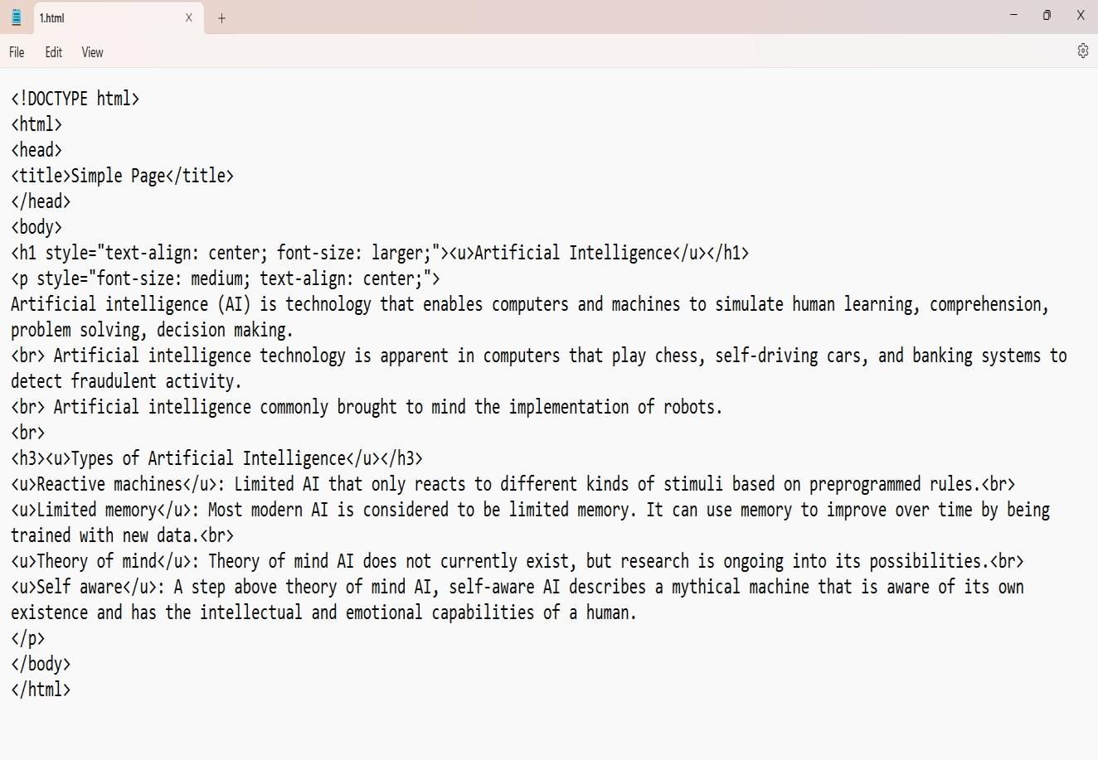



**EXPERIMENT:2**

**Experiment 2:-** Create a simple HTML page using basic tags. . Student Name: deepak

Roll No: 23/SCA/BCA/078

Date of Performance: 09-08-2024

1. **Aim/Overview of the practical:**

To Create a simple HTML page using basic tags

**Result/Output/Writing Summary:**

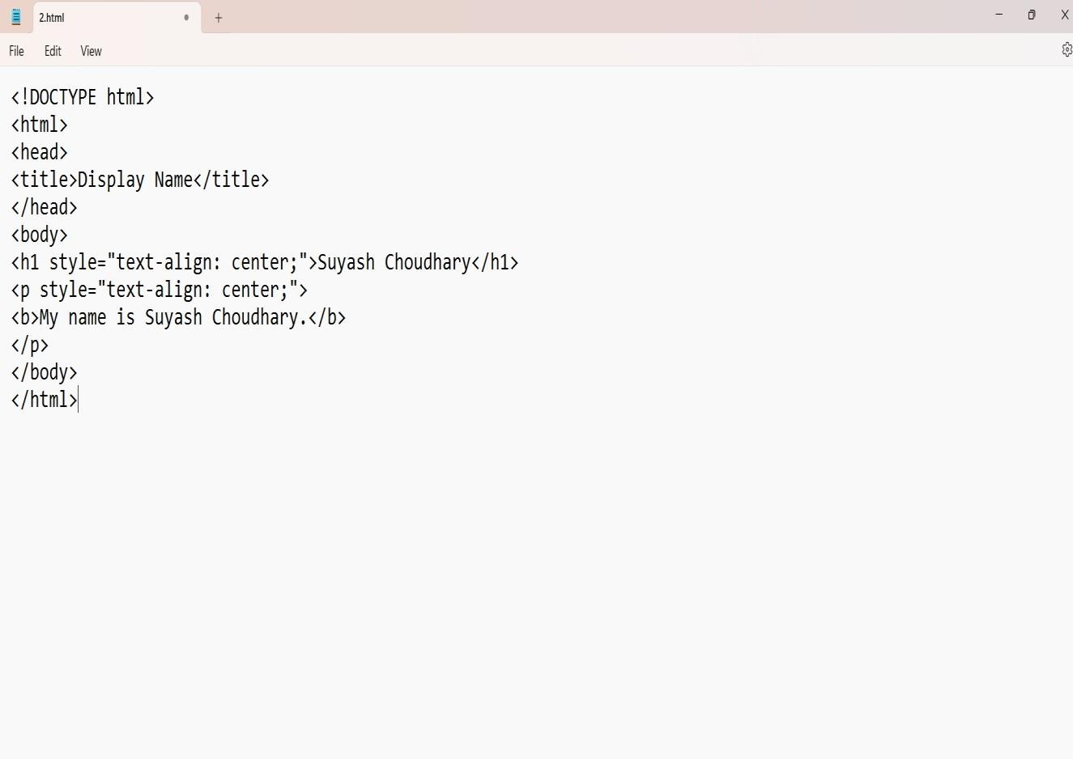

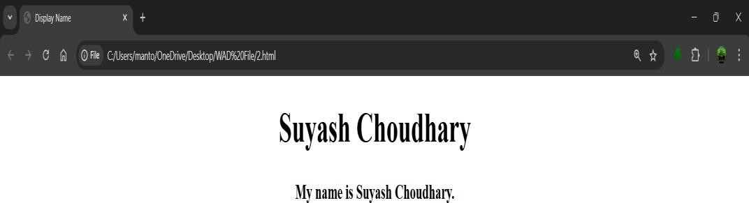

## Experiment:3

**Experiment 3:-** Create a web page and show the output from 1 to 10 in separate lines .

Student Name: deepak

Roll No: 23/SCA/BCA/078

Date of Performance: 09-08-2024

* 1. **Aim/Overview of the practical:**

To Create a web page and show the output from 1 to 10 in separate lines .

**Output/Writing Summary:**

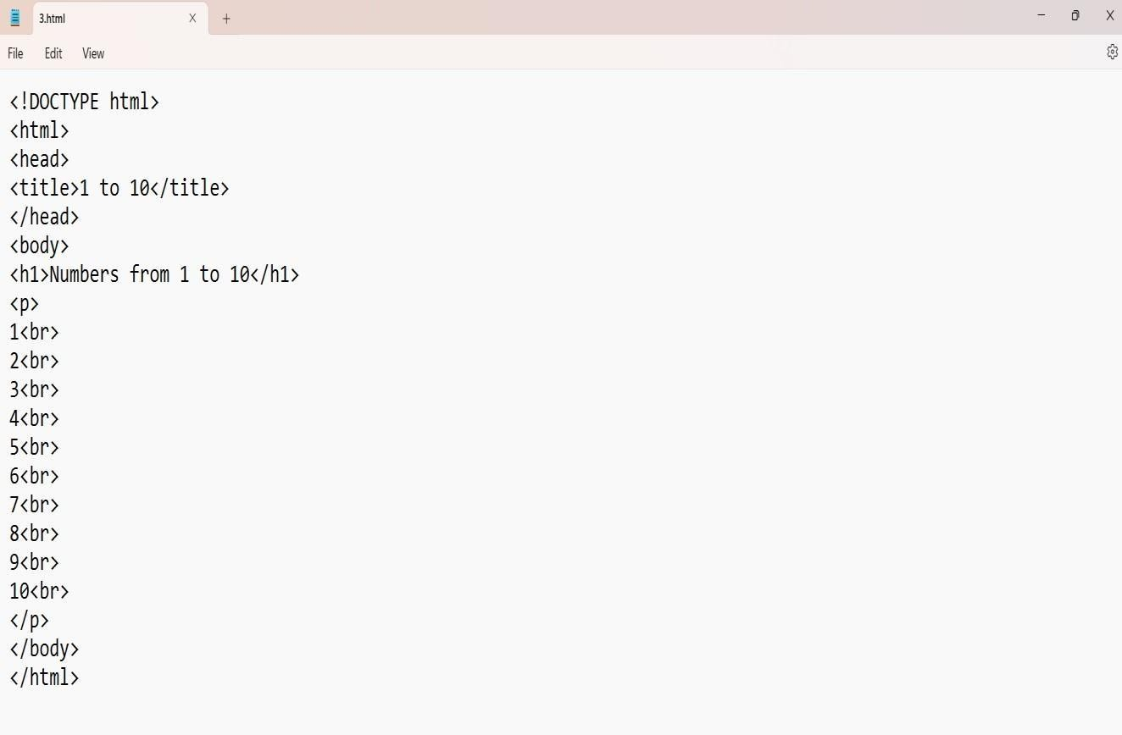

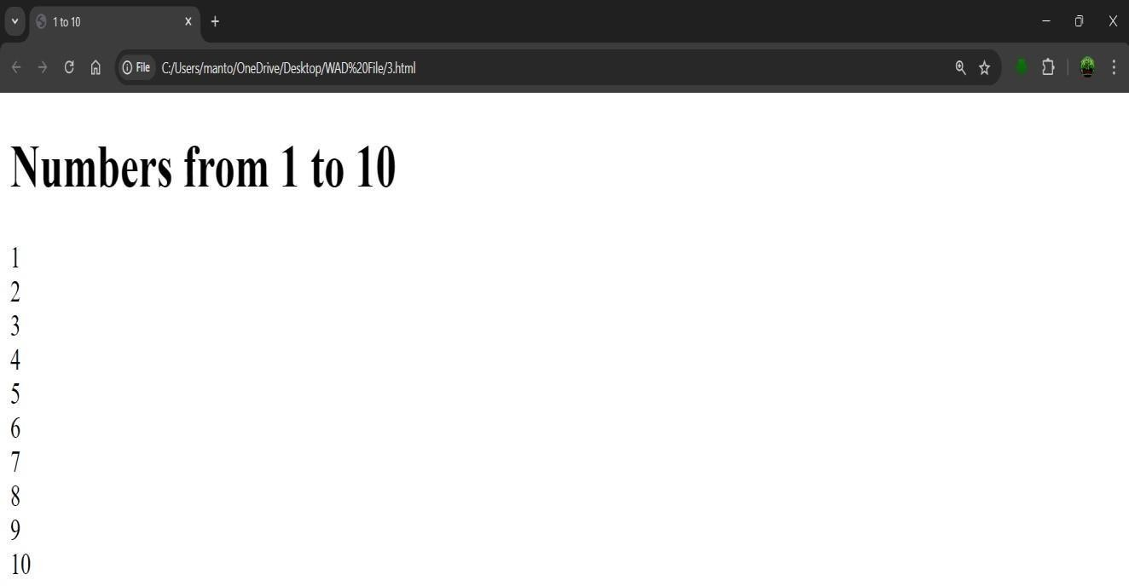

## Experiment:4

**Experiment 4:-** Create a web page and show the output from 1 to 10 in separate lines, each number being in different colour.

Student Name: deepak

Roll No: 23/SCA/BCA/078

Date of Performance: 16-08-2024

**1. Aim/Overview of the practical:**

To Create a web page and show the output from 1 to 10 in separate lines, each number being in different colour

**Result/Output/Writing Summary:**

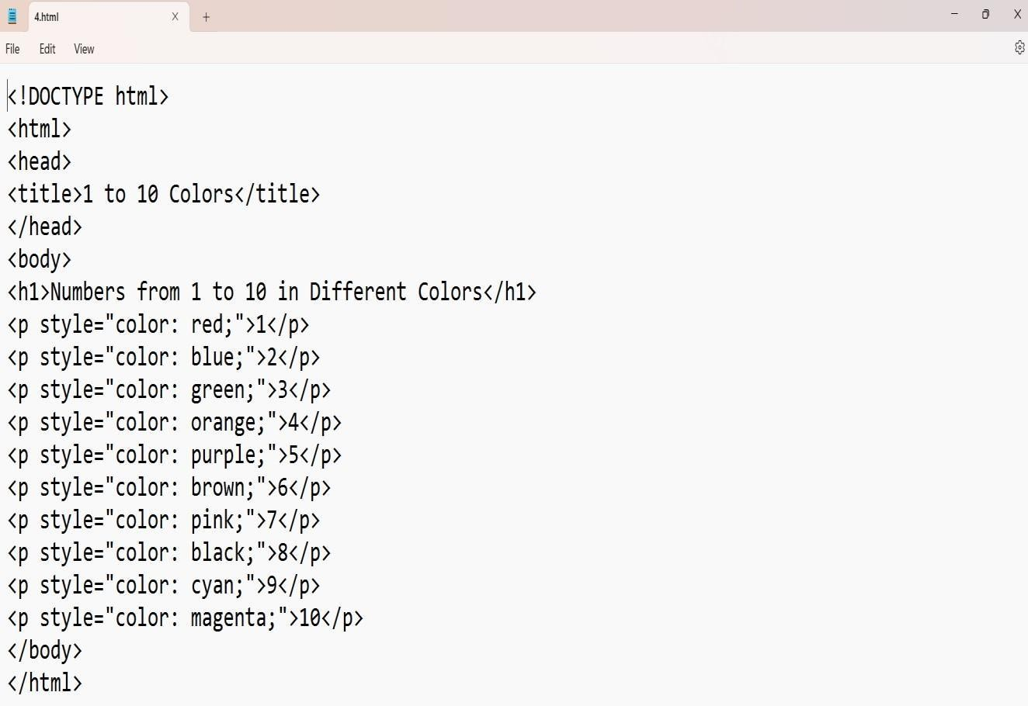

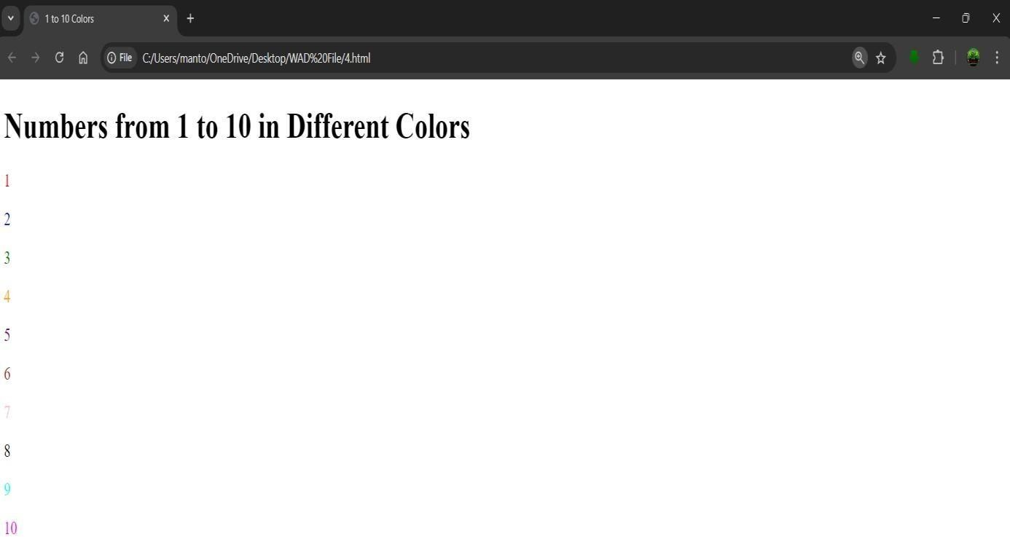

## Experiment No: 5

**Experiment 5:-** Make a picture as a background on the web pages Student Name: deepak

Roll no: 23/SCA/BCA/078

Date of Performance: 16-08-2024

**1. Aim/Overview of the practical:**

To Make a picture as a background on the web pages

.

**Result/Output/Writing Summary:**

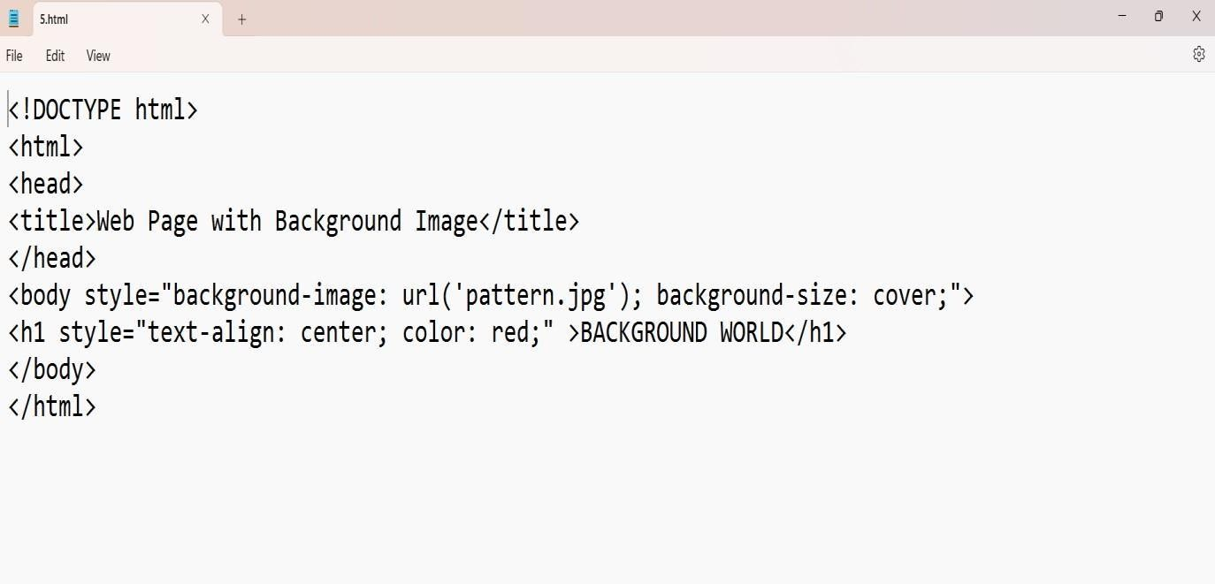

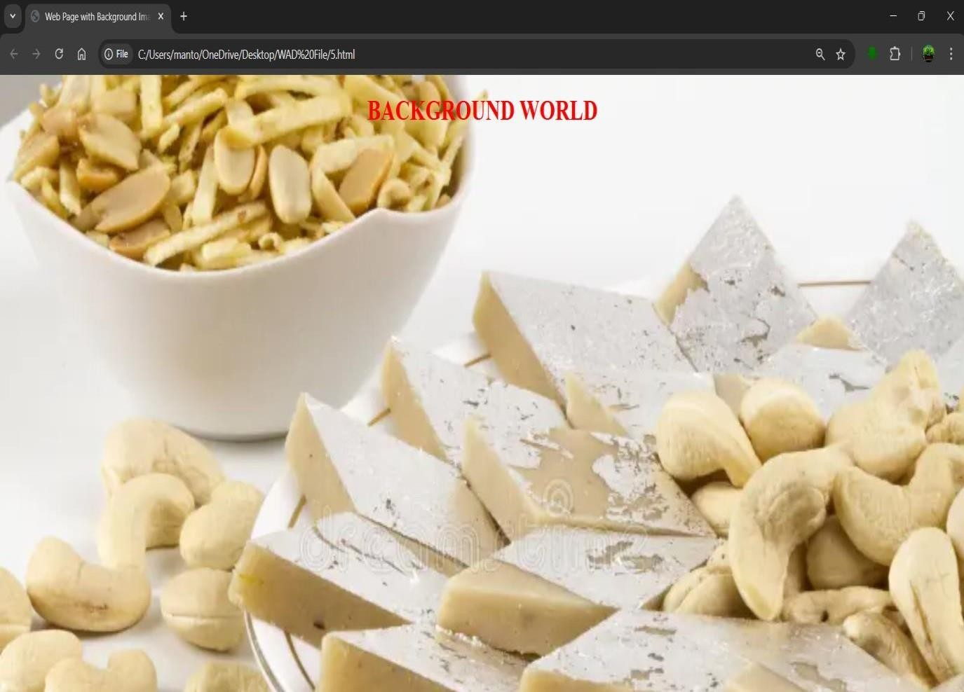g

## Experiment No: 6

**Experiment 6:-** Create a web page to print a paragraph with 4-5 sentences, each sentence shall have a different font.

Student Name: deepak

Roll No: 23/SCA/BCA/078

Date of Performance: 23-08-2024

**1. Aim/Overview of the practical:**

To Create a web page to print a paragraph with 4-5 sentences, each sentence shall have a different font

**Result/Output/Writing Summary:**

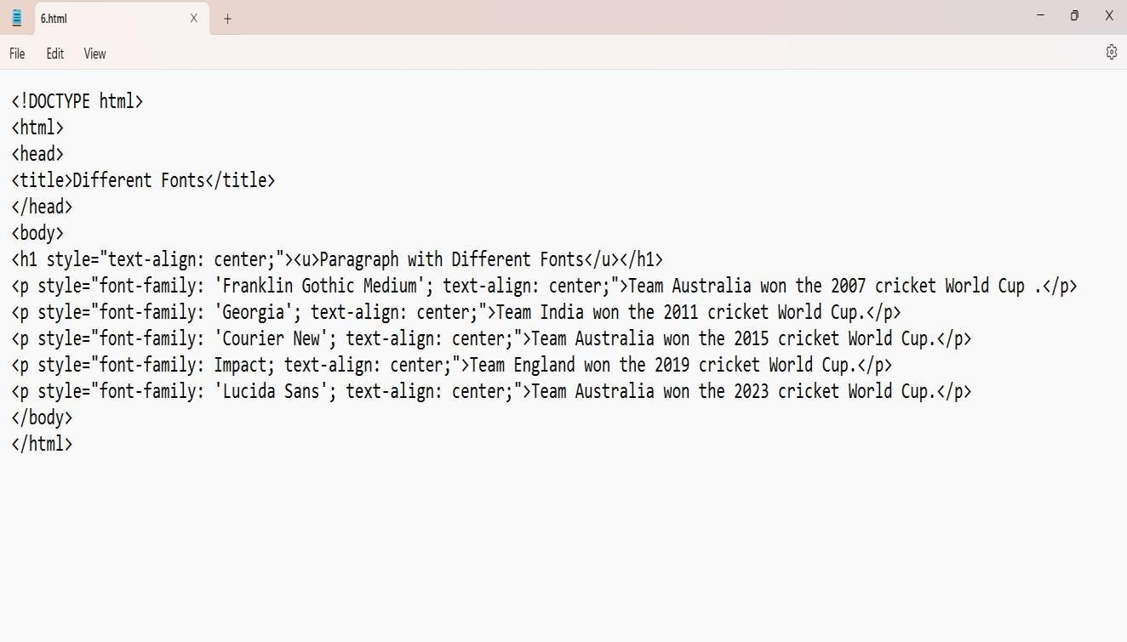

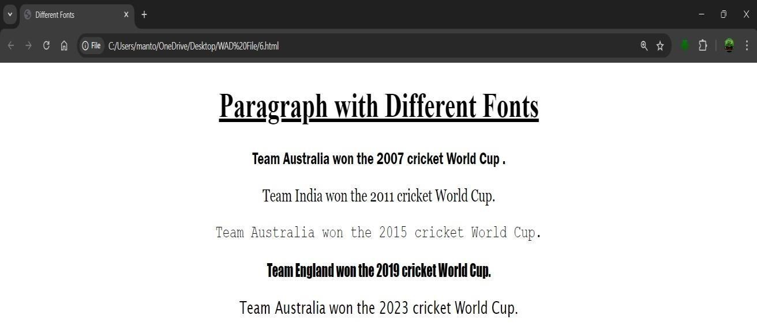

## EXPERIMENT:7

**Experiment 7:-** Write HTML code to print a paragraph that is description of a book, it shall include the title of the book, its author name; name and title should be underlined and all adjectives shall be bold and Italics

Student Name: deepak

Roll No: 23/SCA/BCA/078

Date of Performance: 23-08-2024

**1. Aim/Overview of the practical:**

To Create HTML code to print a paragraph that is description of a book, it shall include the title of the book, its author name; name and title should be underlined and all adjectives shall be bold and Italics

**Result/Output/Writing Summary:**

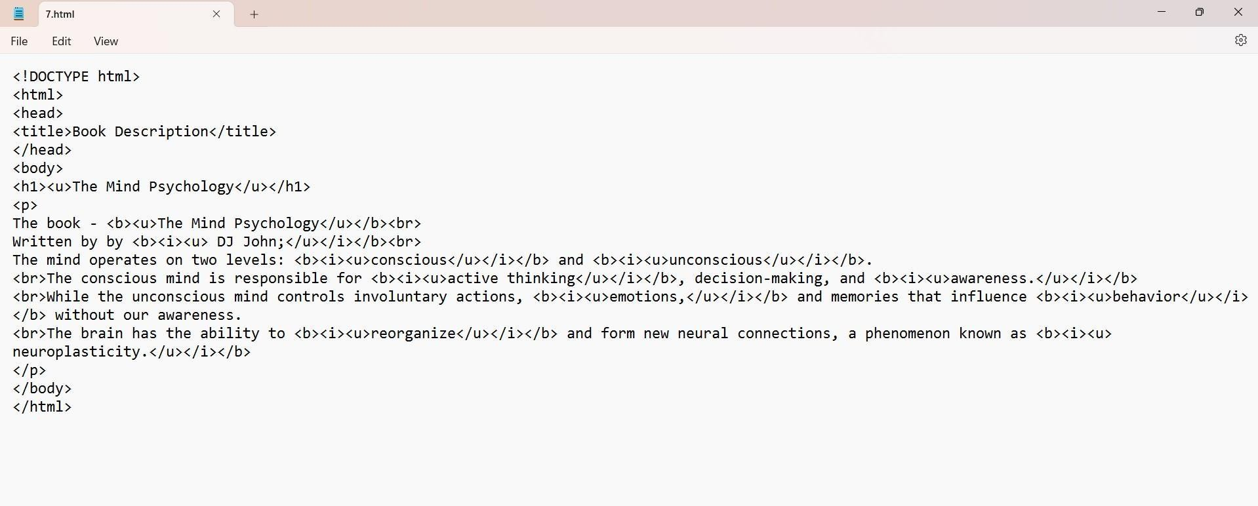

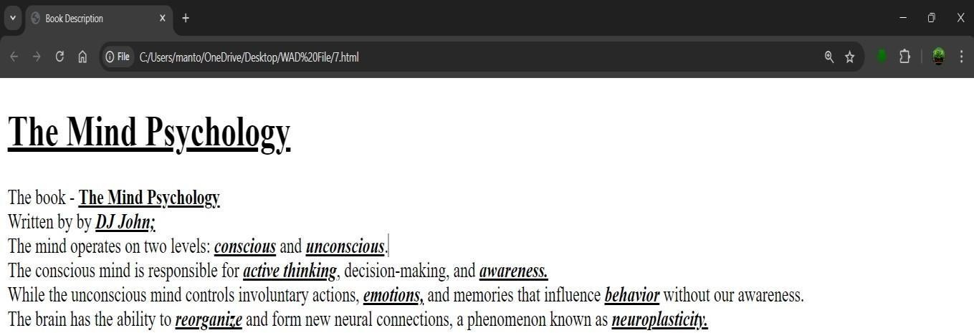

## Experiment:8

**Experiment 8:-** Write HTML code to print your name using Heading tag, every letter shall be of different heading size.

Student Name: deepak

Roll No: 23/SCA/BCA/078

Date of Performance: 30-08-2024

**1. Aim/Overview of the practical:**

To Create HTML code to print your name using Heading tag, every letter shall be of different heading size.

**Result/Output/Writing Summary:**

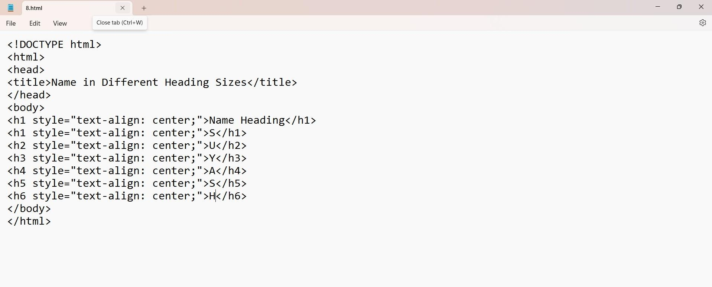

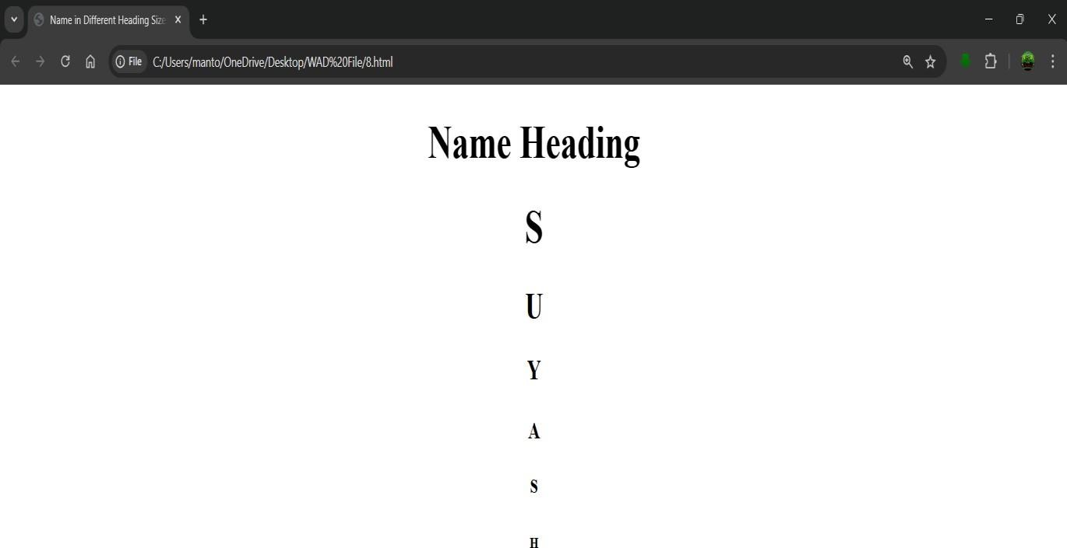

## Experiment:9

**Experiment 9:-** Write HTML code to print the sequence of numbers 1-20. Each number shall be in different line with number 2 next to it as subscript, an equal sign and the result.

Student Name: deepak

Roll No: 23/SCA/BCA/078

Date of Performance: 30-08-2024

**1. Aim/Overview of the practical:**

To Create a HTML code to print the sequence of numbers 1-20. Each number shall be in different line with number 2 next to it as subscript, an equal sign and the result.

**Result/Output/Writing Summary:**

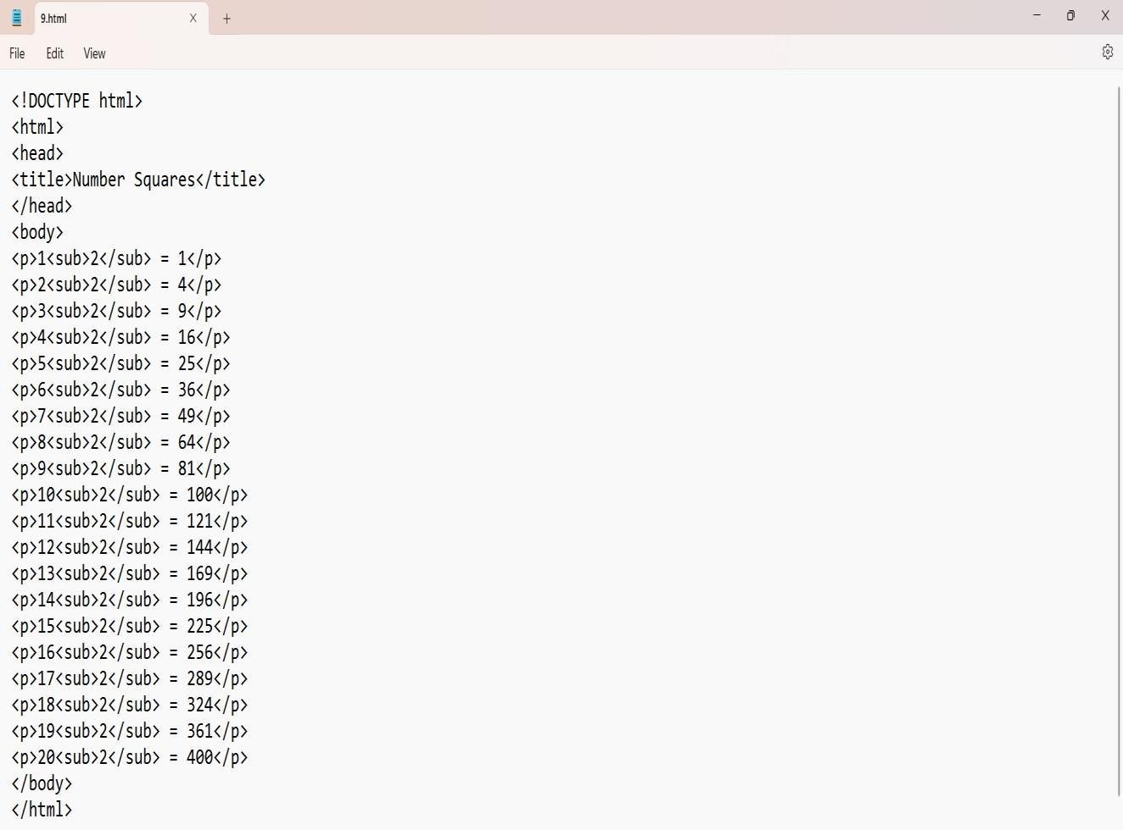

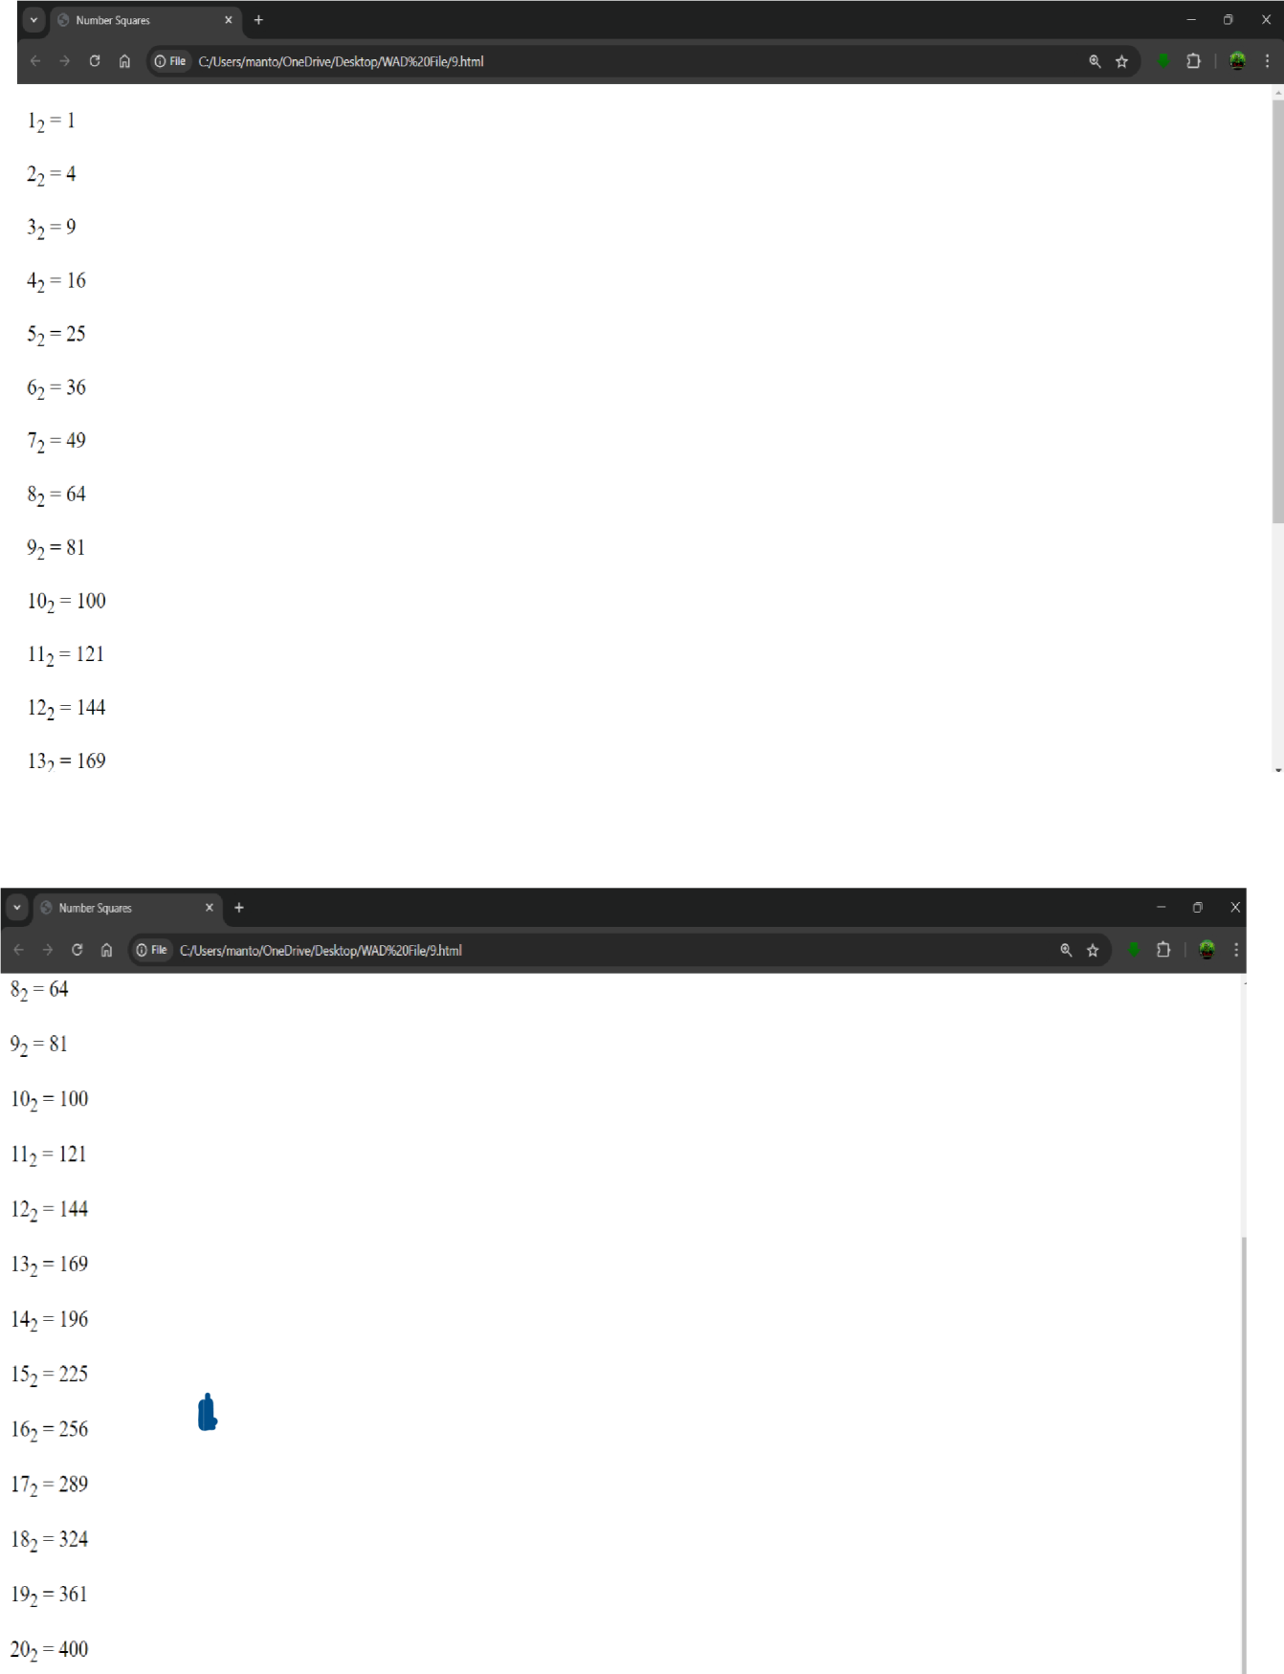

## Experiment No: 10

**Experiment 10:-** Write HTML code to display an image with border of size with width 200, height 200 pixels, leaving Hspace and Vspace of your choice with image hanging in the right side on the screen.

Student Name: deepak

Roll no: 23/SCA/BCA/078

Date of Performance: 06-09-2024

**1. Aim/Overview of the practical:**

To Create a HTML code to display an image with border of size with width 200, height 200 pixels, leaving Hspace and Vspace of your choice with image hanging in the right side on the screen.

**Result/Output/Writing Summary:**

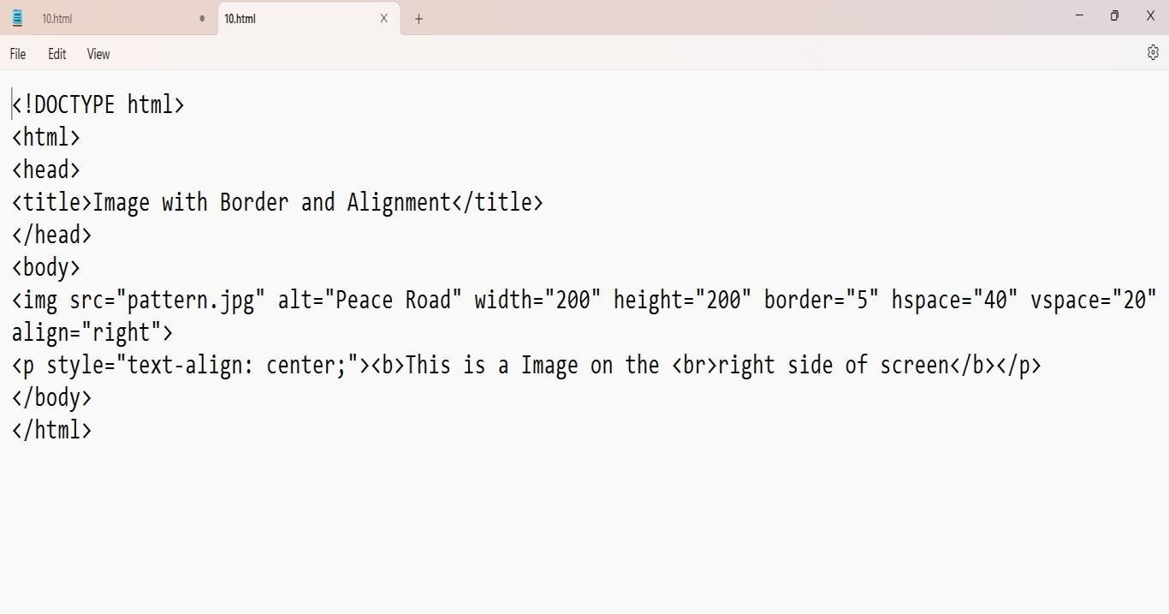

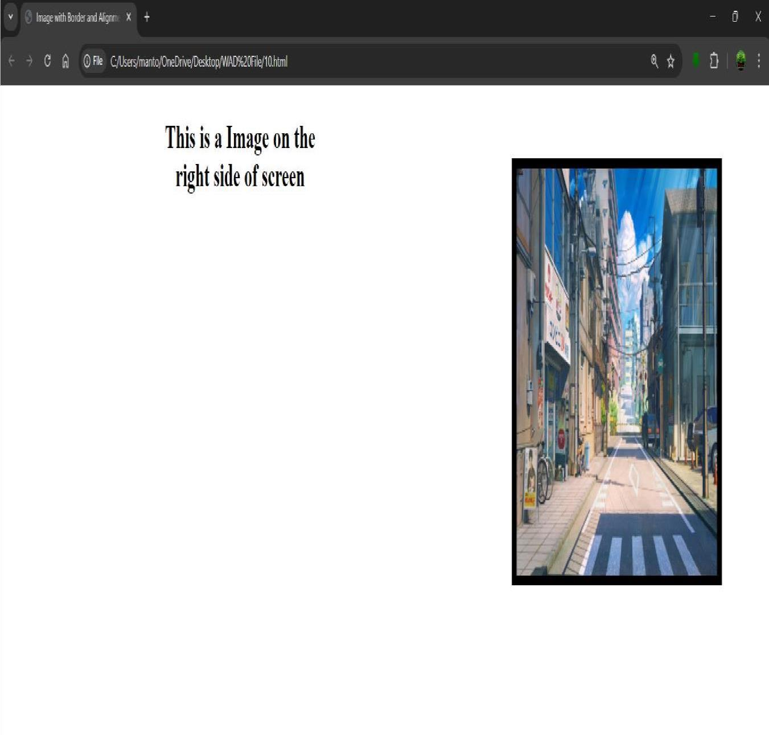

## Experiment No: 11

**Experiment 11:-** Write HTML code to create a web page with heading. The heading shall be displayed at the top-center of the page and the image shall be at the center, just below the heading.

Student Name: deepak

Roll No: 23/SCA/BCA/78

Date of Performance: 06-09-2024

**1. Aim/Overview of the practical:**

To Create a HTML code to create a web page with heading. The heading shall be displayed at the top-center of the page and the image shall be at the center, just below the heading.

**Result/Output/Writing Summary:**

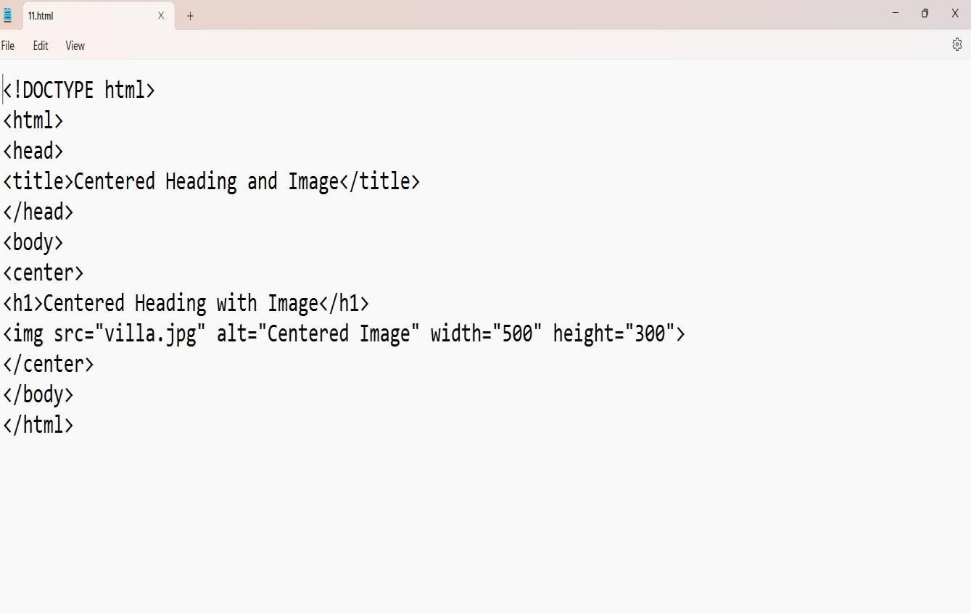

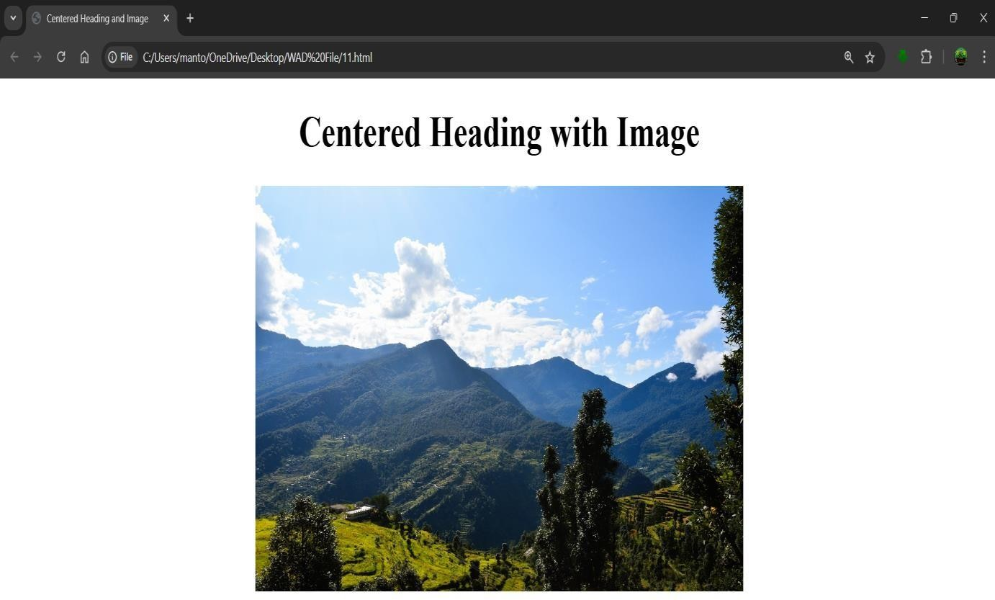

## EXPERIMENT:12

**Experiment 12:** Write HTML code using Multimedia tags. Student Name: deepak

Roll No: 23/SCA/BCA/078

Date of Performance: 13-09-2024

1. **Aim/Overview of the practical:**

To Create a HTML code using Multimedia tags

**Result/Output/Writing Summary:**

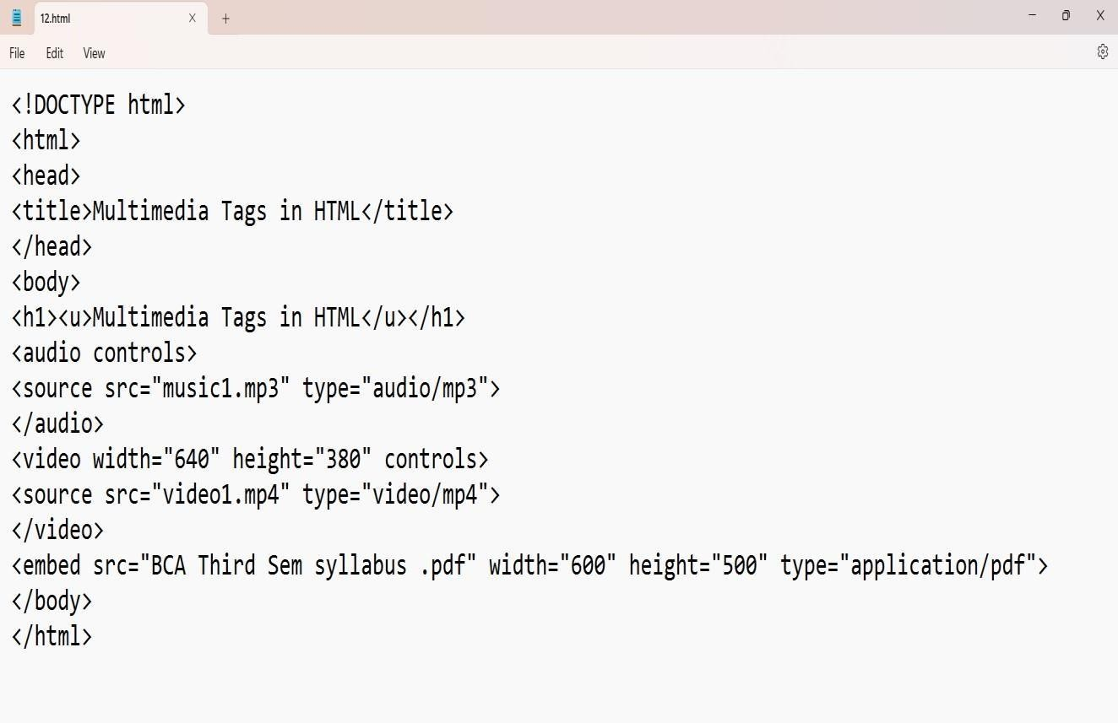

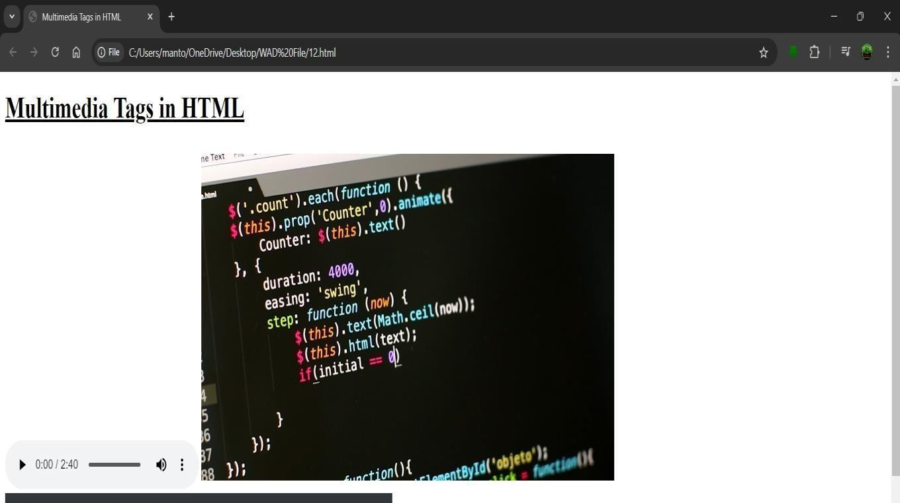

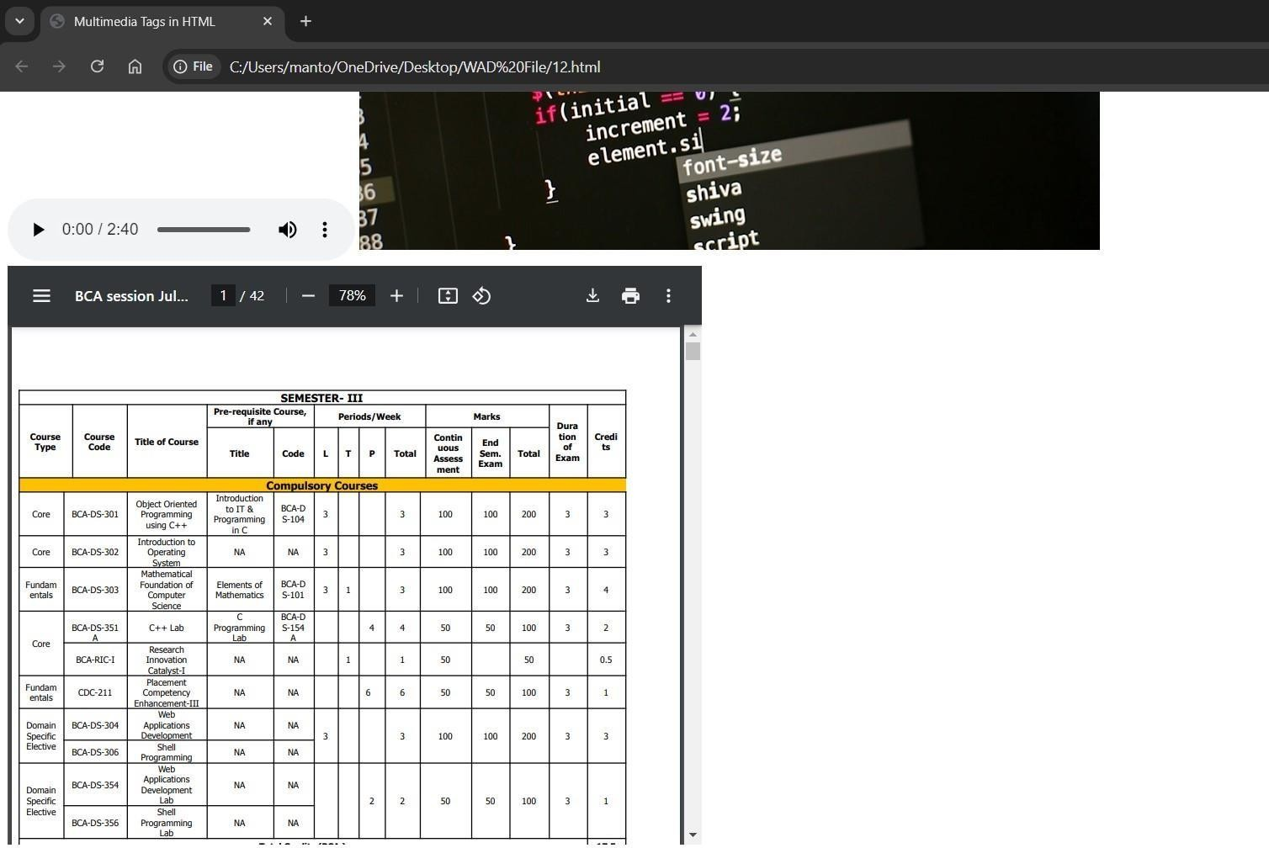

## Experiment No: 13

**Experiment 13:-** Create a Table using Rowspan and Colspan taking example of student Record.

Student Name: deepak

Roll No: 23/SCA/BCA/078

Date of Performance: 13-09-2024

* 1. **Aim/Overview of the practical:**

To Create a Table using Rowspan and Colspan taking example of student Record.

**Result/Output/Writing Summary:**

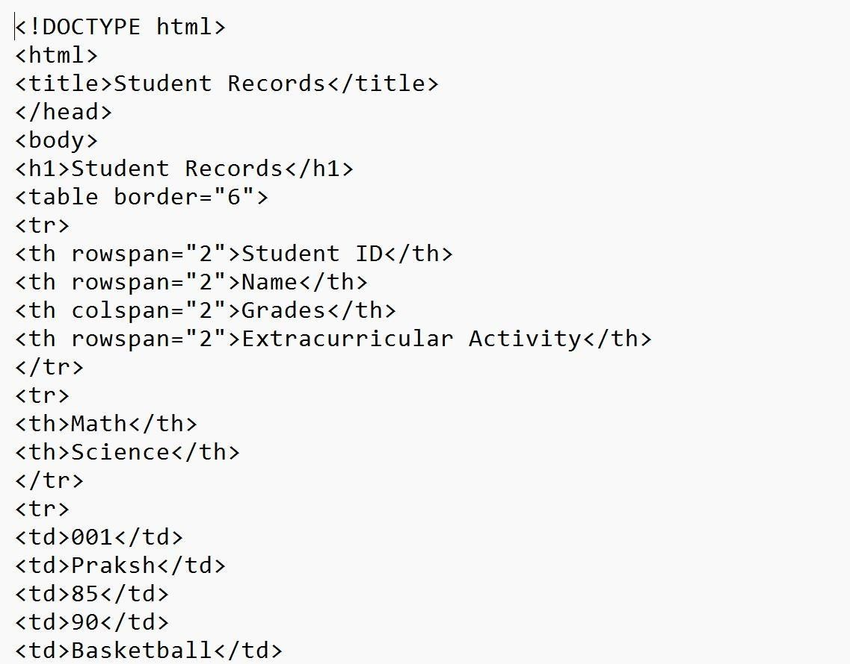

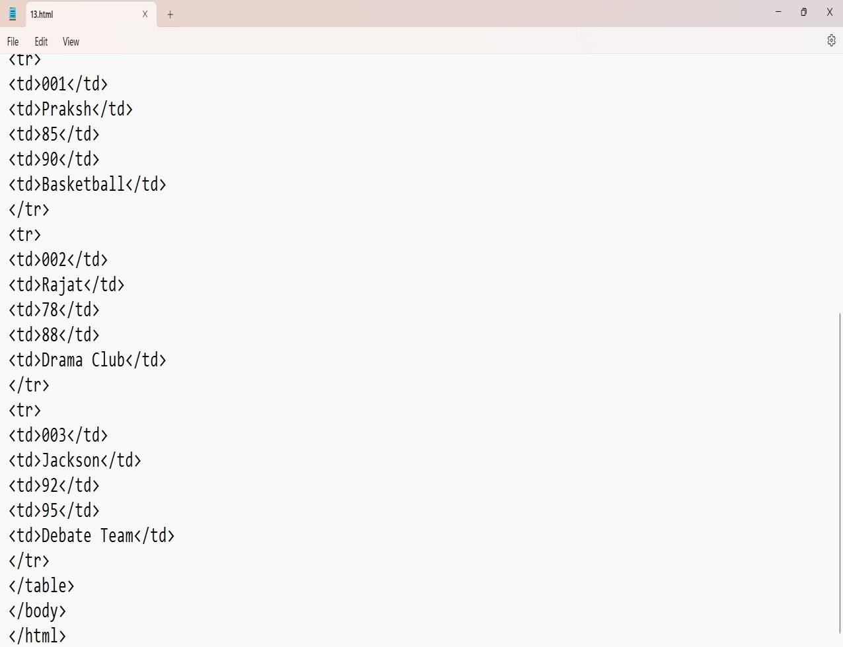

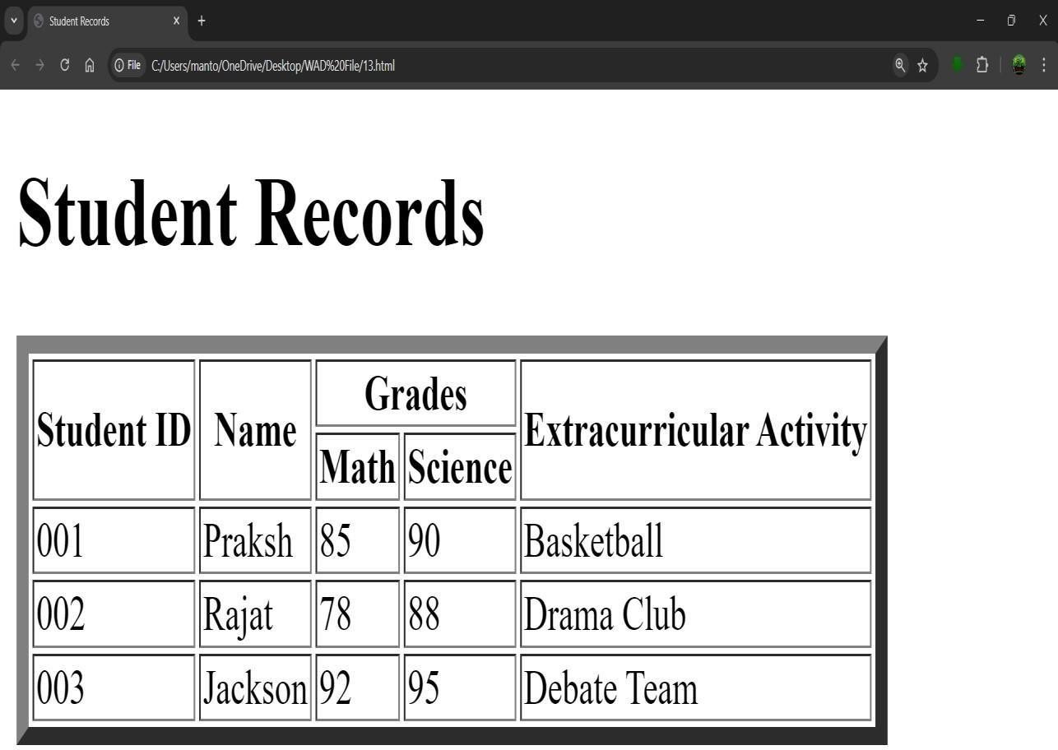

## Experiment No: 14

**Experiment 14:-** Write HTML code using table tag and cellpadding and cellspacing as its attributes.

Student Name: deepak

Roll No: 23/SCA/BCA/078

Date of Performance: 27-09-2024

**1. Aim/Overview of the practical:**

To Create a HTML code using table tag and cellpadding and cellspacing as its attributes.

**Result/Output/Writing Summary:**

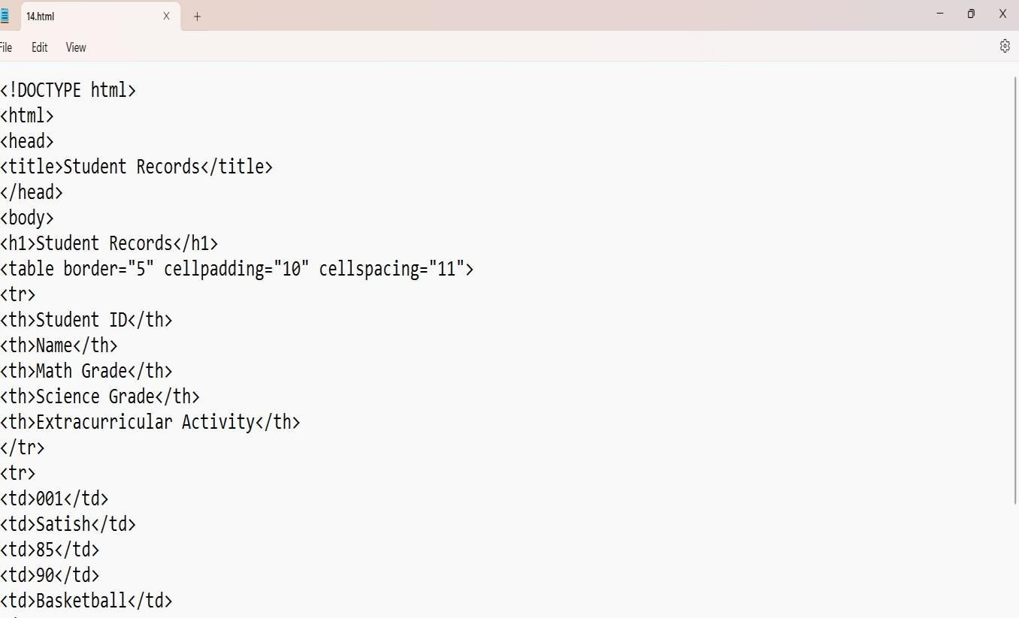

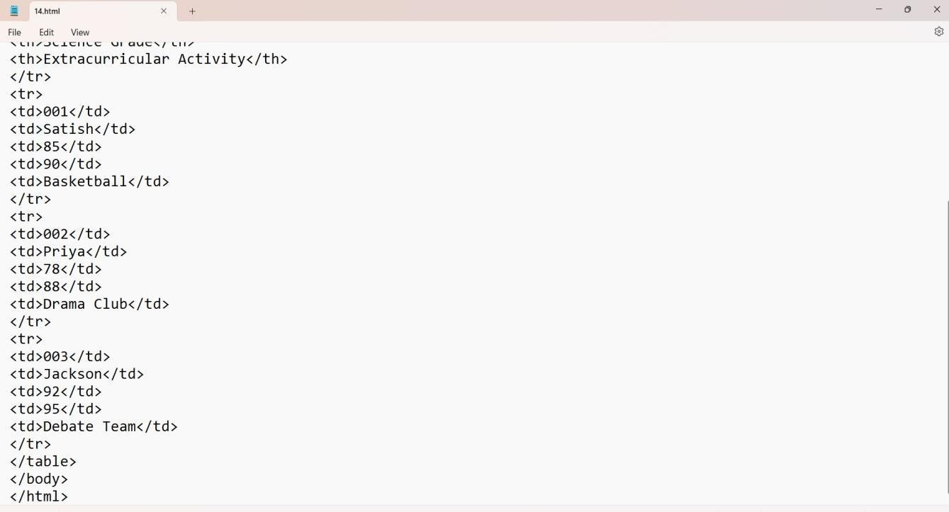

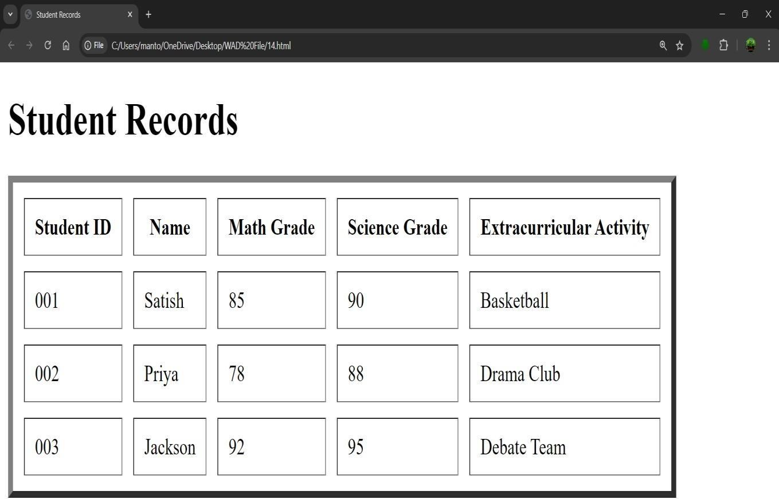

## EXPERIMENT:15

**Experiment 15:-** Create unordered, ordered and definition Lists taking example of your subjects in MCA IST, IInd and IIIrd semester.

Student Name: deepak

Roll No: 23/SCA/BCA/078

Date of Performance: 27-09-2024

**1. Aim/Overview of the practical:**

To Create unordered, ordered and definition Lists taking example of your subjects in MCA IST, IInd and IIIrd semester.

**Result/Output/Writing Summary:**

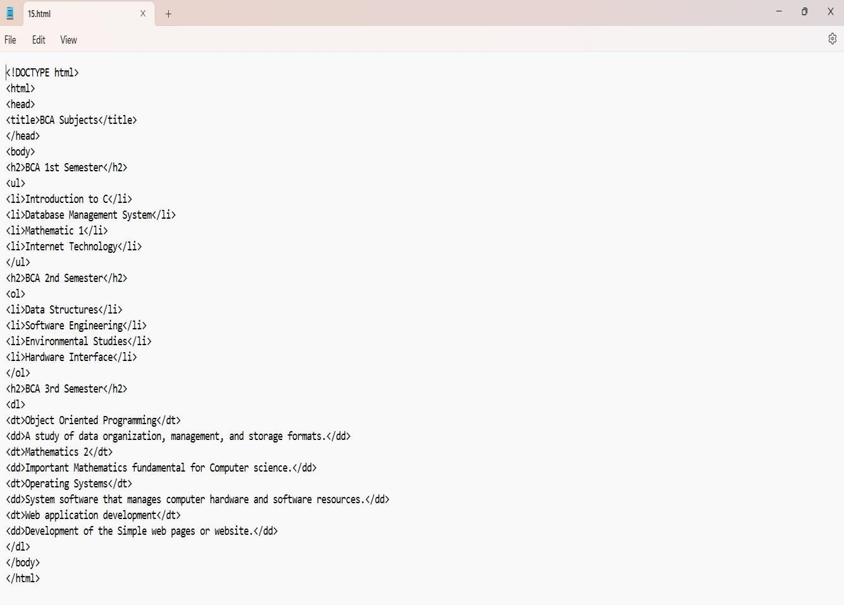

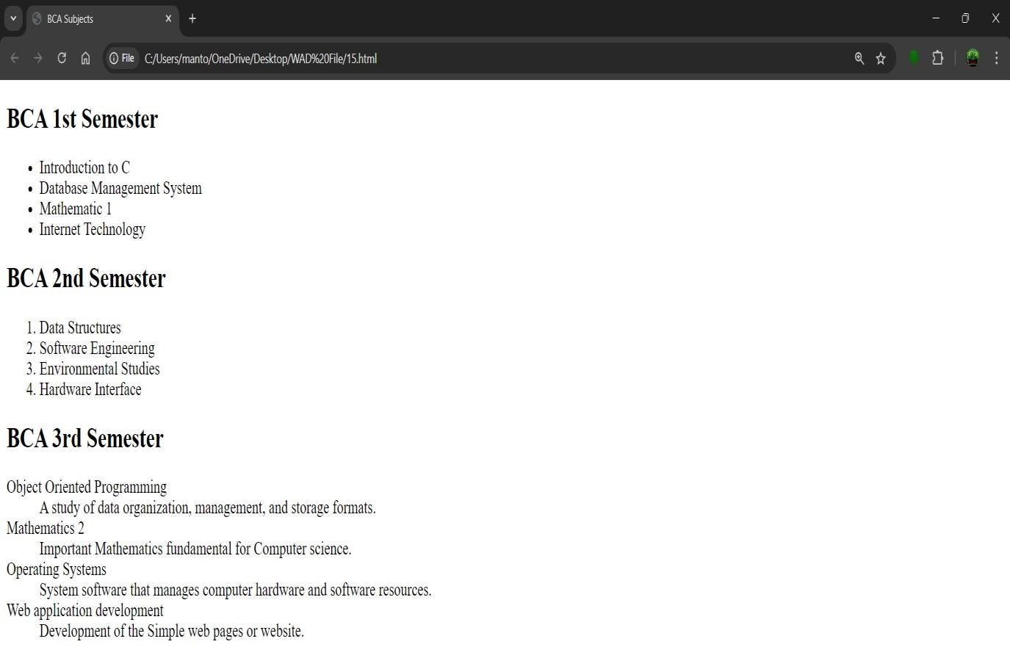

–––

# Experiment No: 16

**Experiment 16:-** Write HTML code using <frameset> and <frame> tag with all its attributes

Student Name: deepak

Roll No: 23/SCA/BCA/078

Date of Performance: 27-09-2024

**1. Aim/Overview of the practical:**

To Create a HTML code using <frameset> and <frame> tag with all its attributes

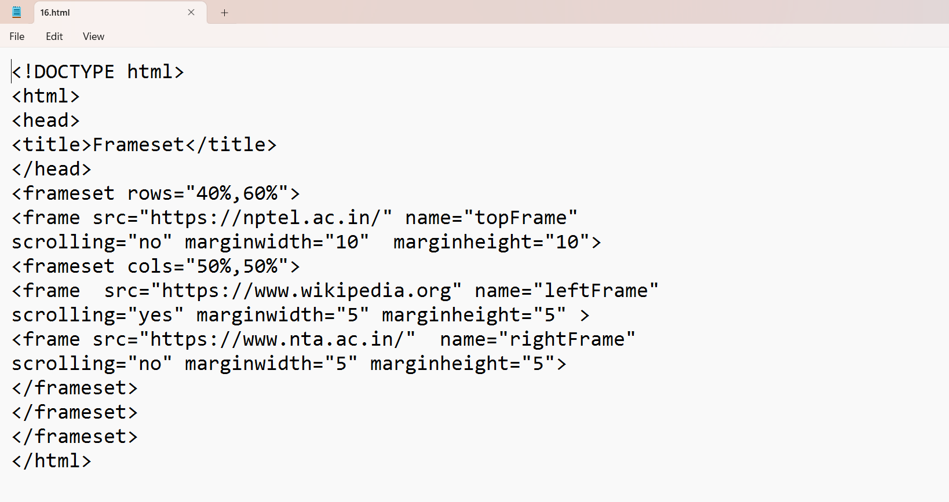

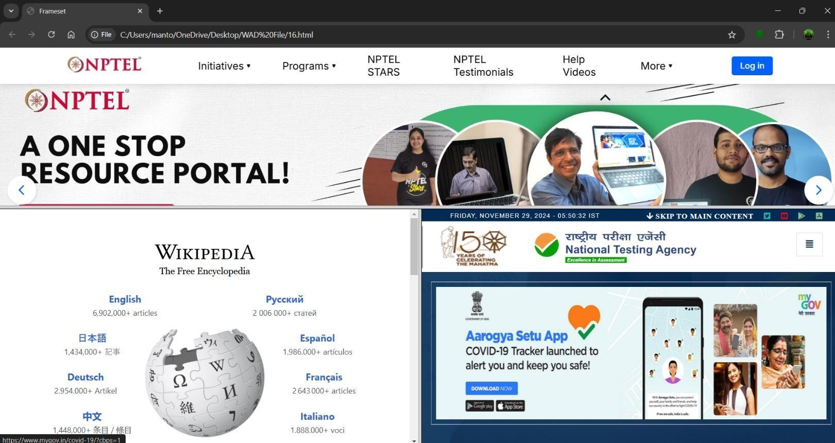

**EXPERIMENT:17**

**Experiment 17:-** Write HTML code to design a form in HTML using controls and buttons such as Teaxtbox, Textarea, password, submit button, browse button, drop- down menu.

Student Name: deepak

Roll No: 23/SCA/BCA/078

Date of Performance: 04-10-2024

1. **Aim/Overview of the practical:**

To Create a HTML code to design a form in HTML using controls and buttons such as Teaxtbox, Textarea, password, submit button, browse button, drop-down menu.

1. **Result/Output/Writing Summary:**

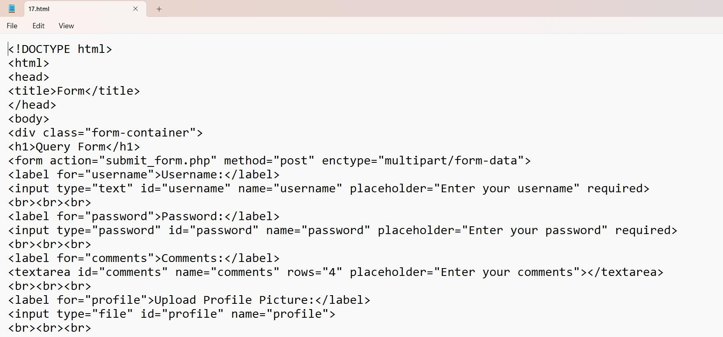

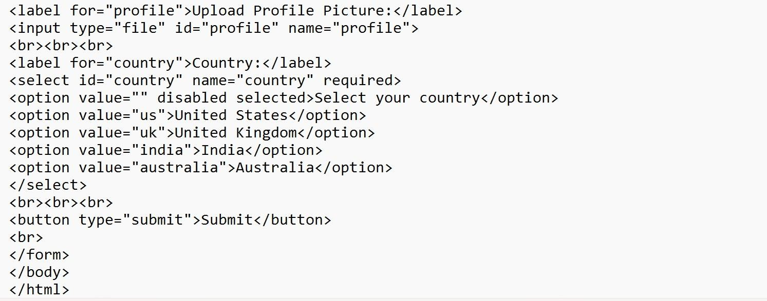

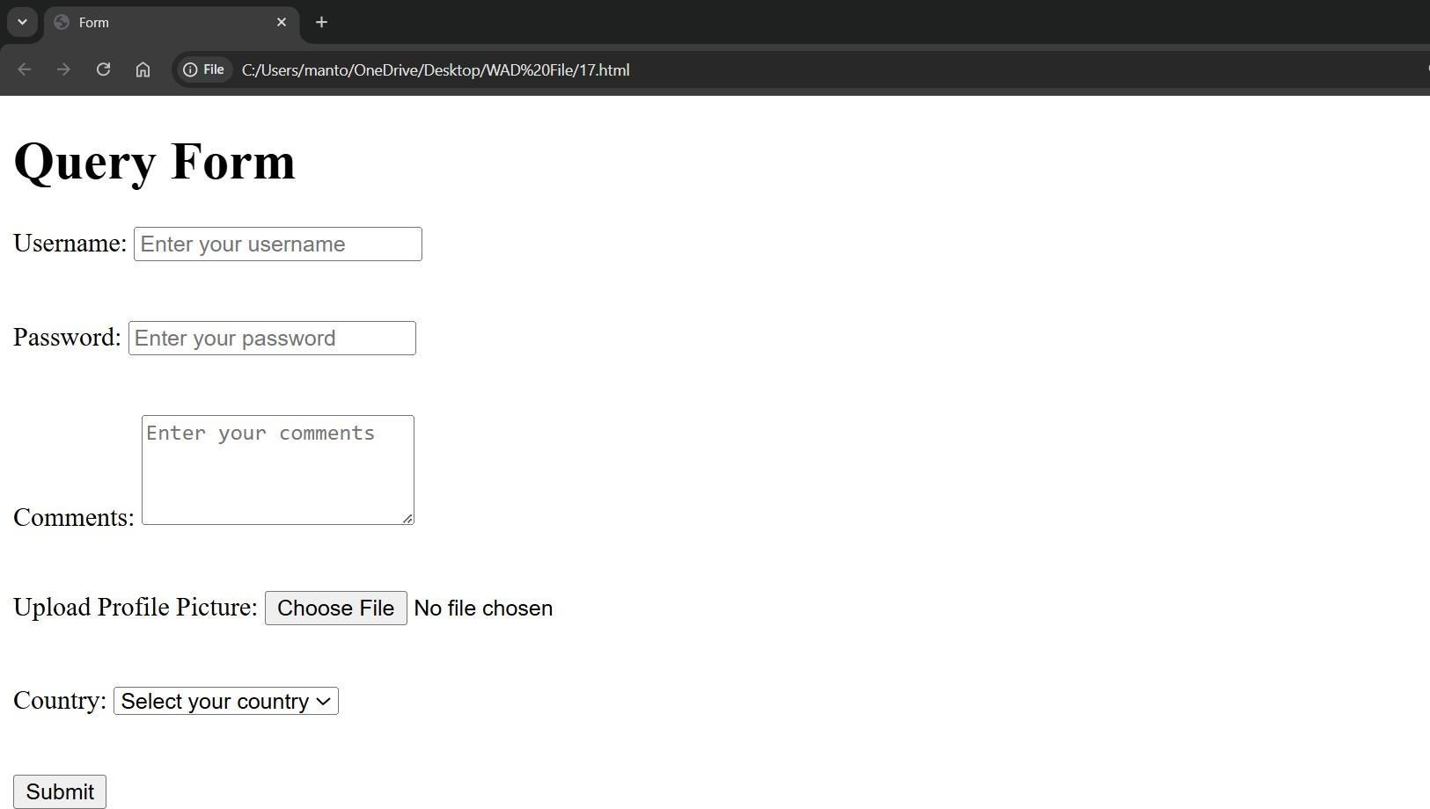

## Experiment:18

**Experiment 18:-** Write HTML code to design a Registration Form in HTML

Student Name: deepak

Roll No: 23/SCA/BCA/078

Date of Performance: 04-10-2024

* 1. **Aim/Overview of the practical:**

To Create a HTML code to design a Registration Form in HTML .

* 1. **Result/Output/Writing Summary:**

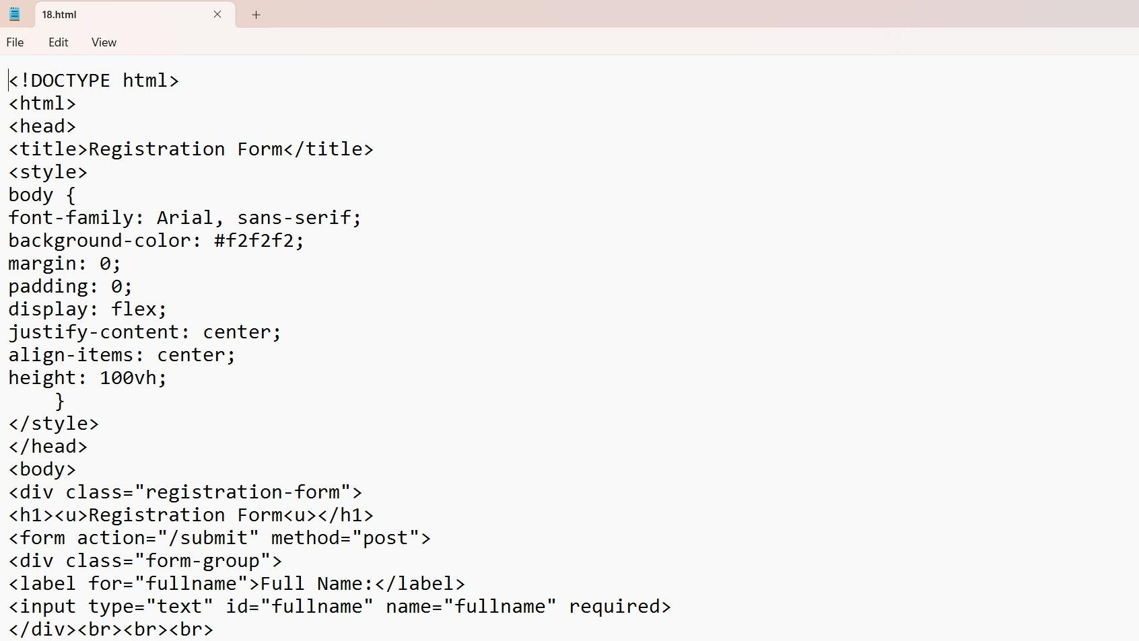

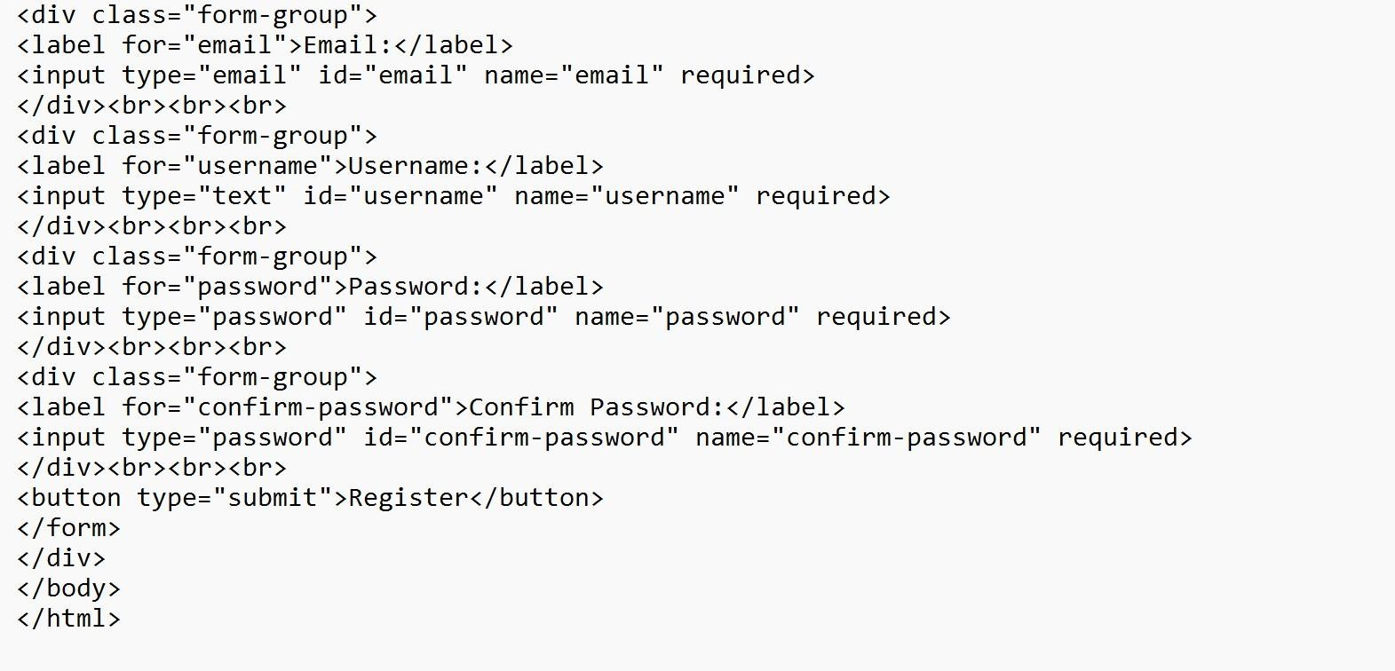

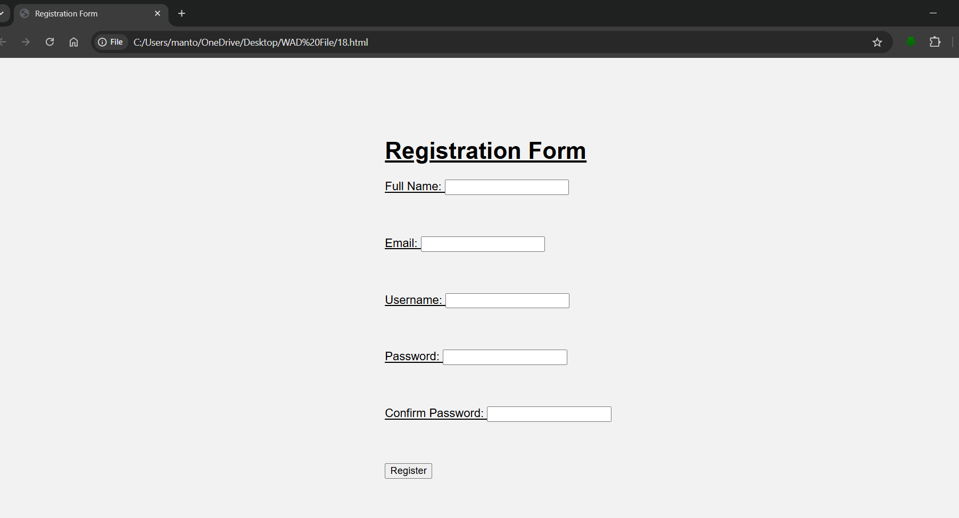

## Experiment:19

**Experiment 19:-** Write HTML code to design a student admission Form in HTML

Student Name: deepak

Roll No: 23/SCA/BCA/078

Date of Performance: 04-10-2024

1. **Aim/Overview of the practical:**

To Create a HTML code to design a student admission Form in HTML

1. **Result/Output/Writing Summary:**

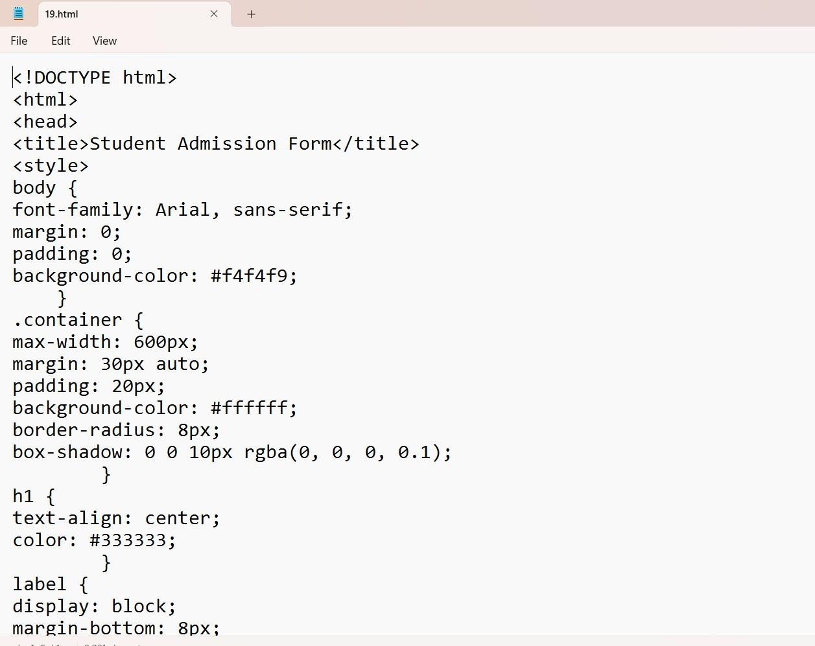

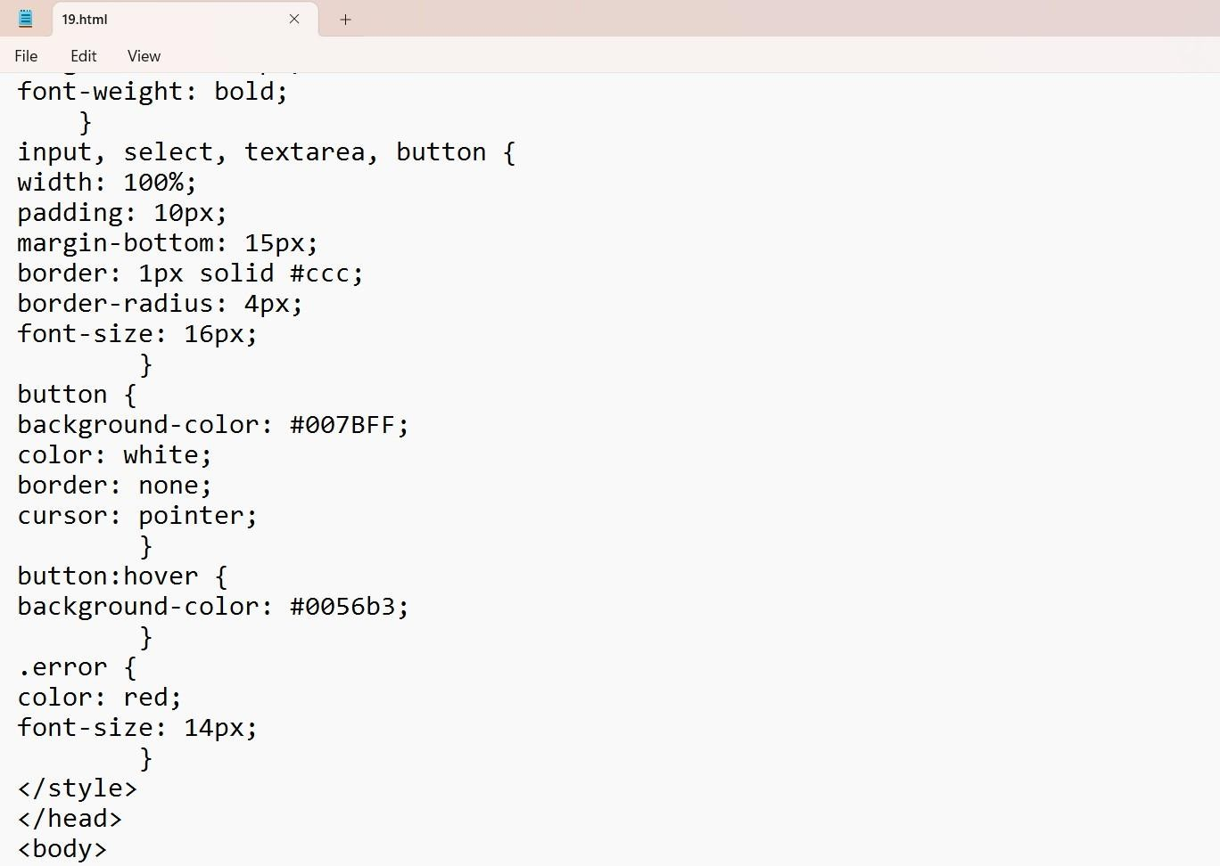

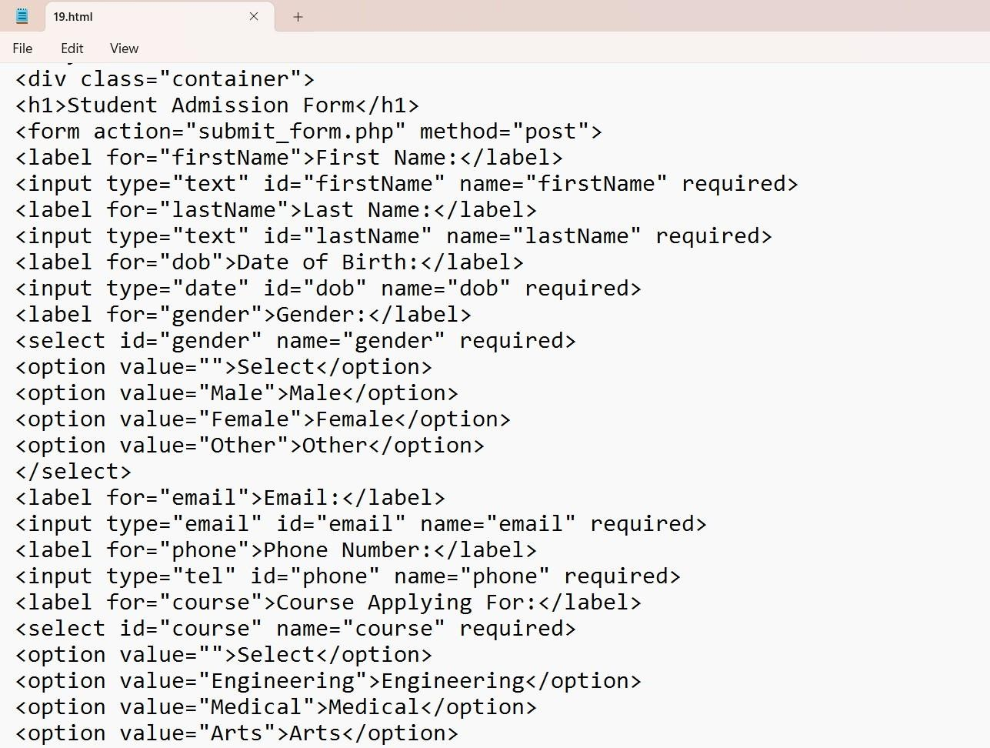

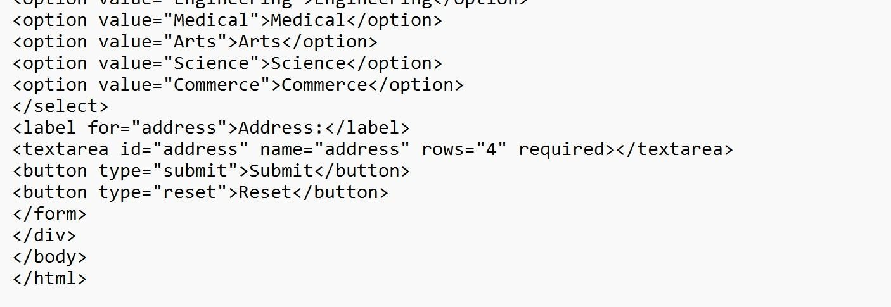

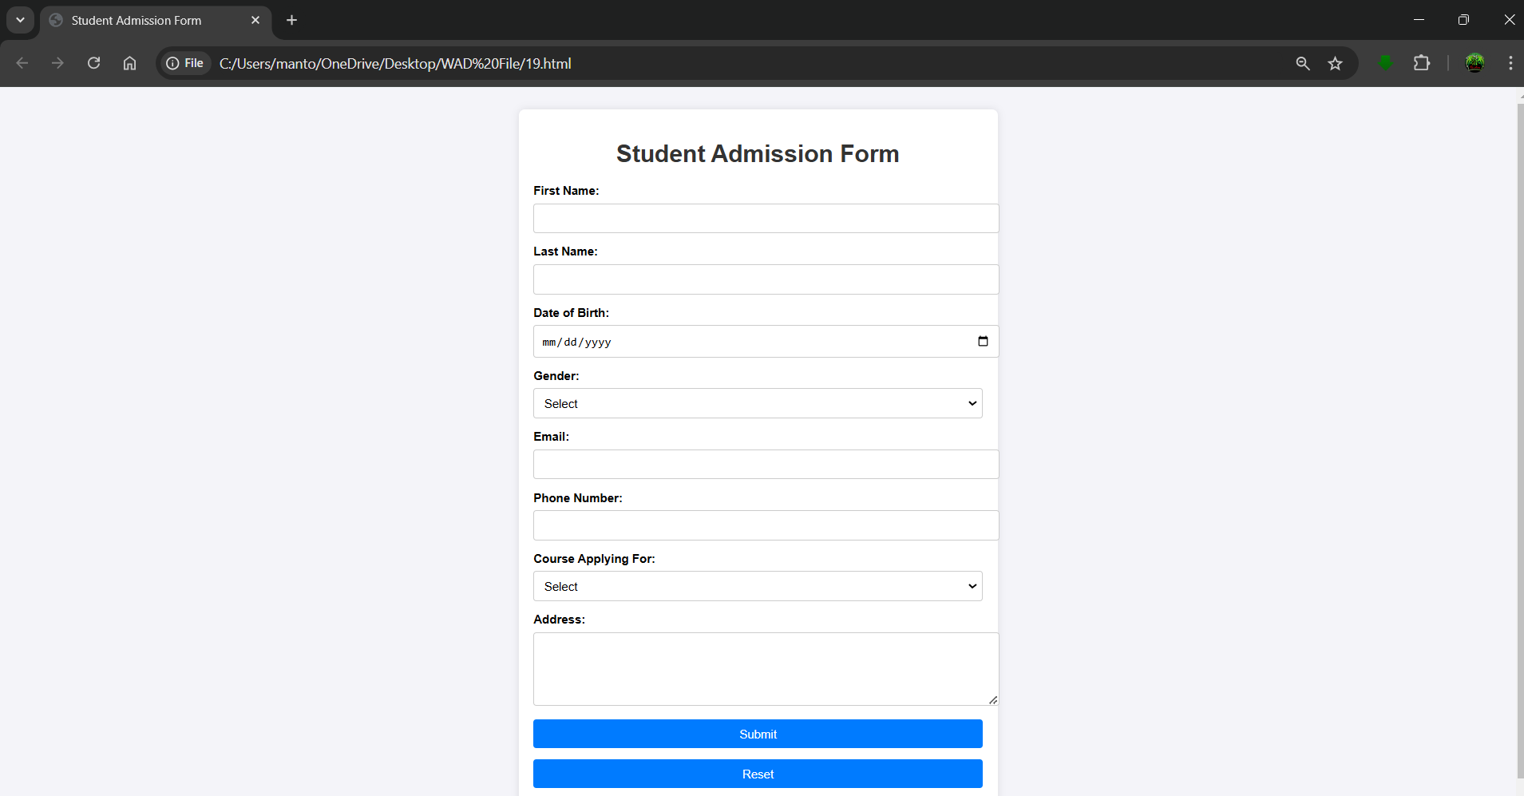

## Experiment No: 20

**Experiment 20:-** Create a proper home page of your own using any components and styles.

Student Name: deepak

Roll no: 23/SCA/BCA/078

Date of Performance: 25-10-2024

**1. Aim/Overview of the practical:**

To Create a proper home page of your own using any components and styles.

2 **Result/Output/Writing Summary:**

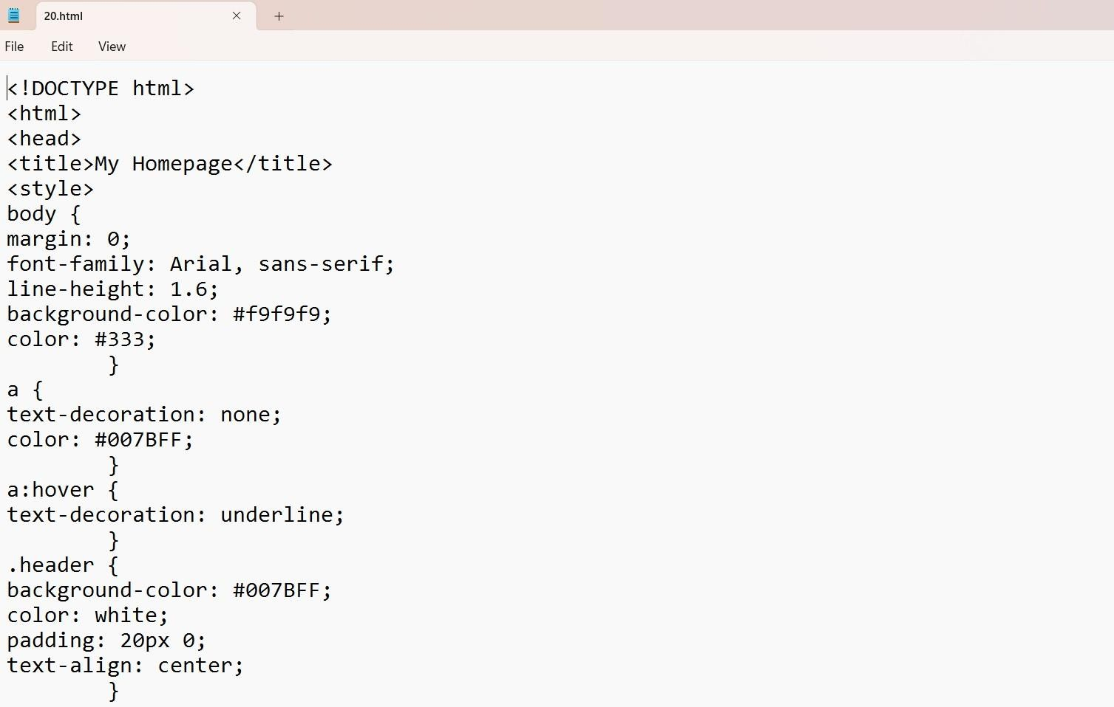

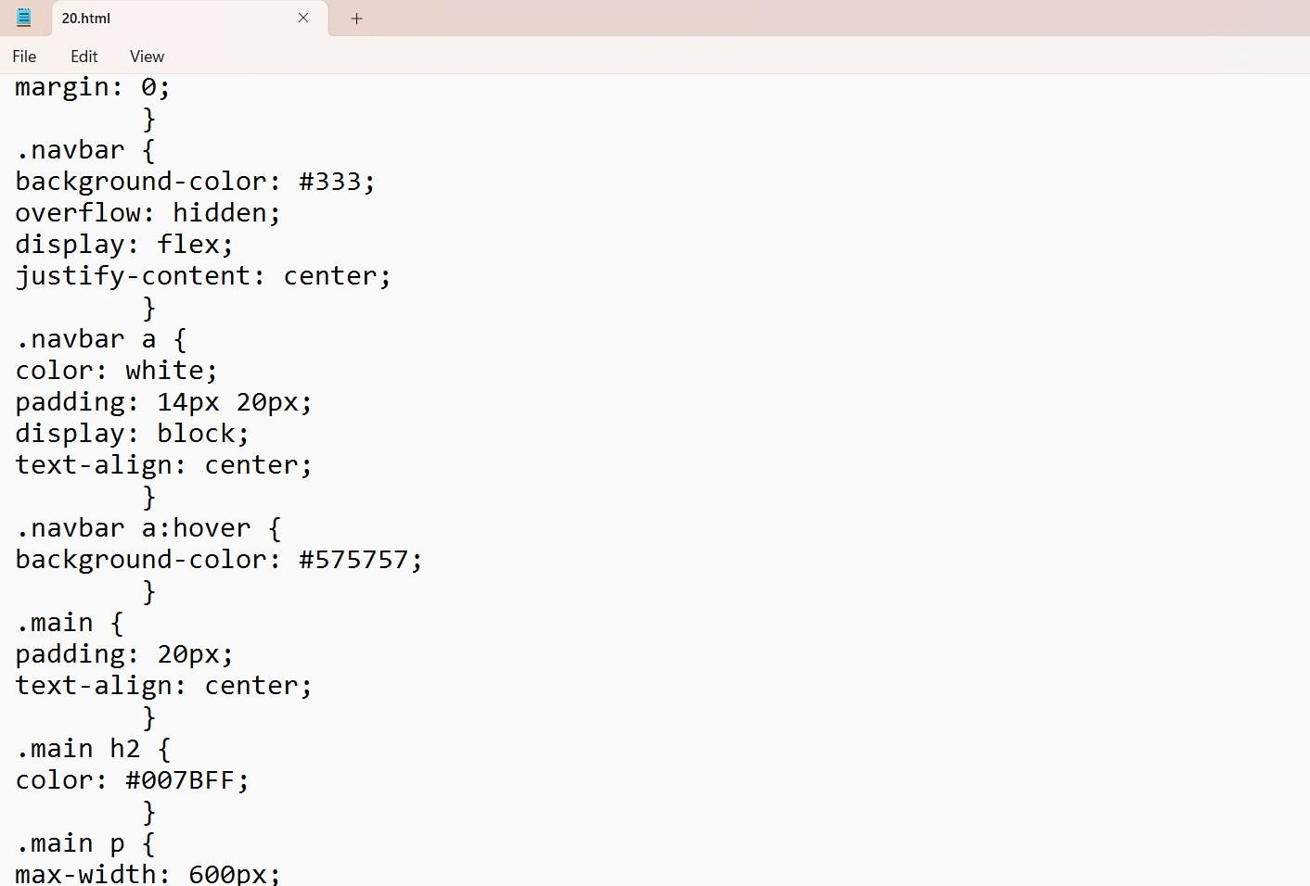

g

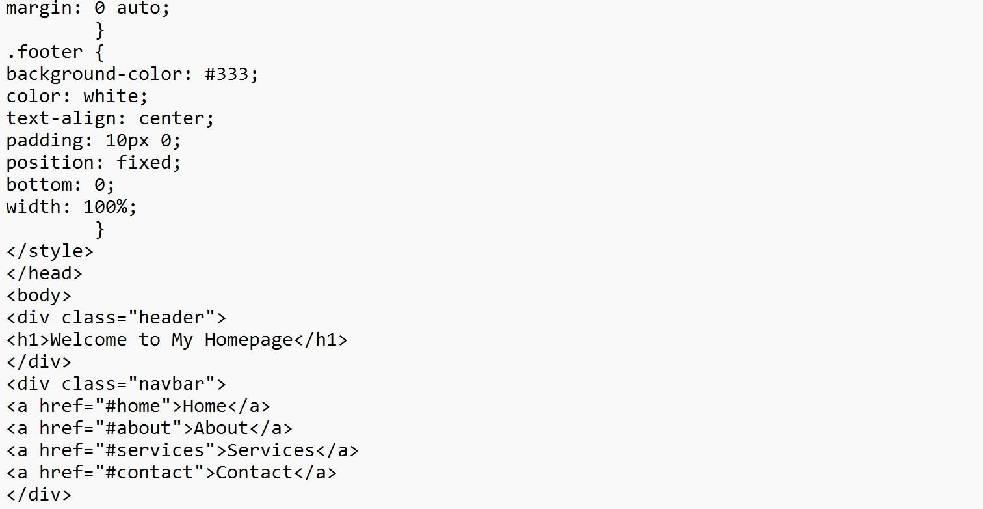

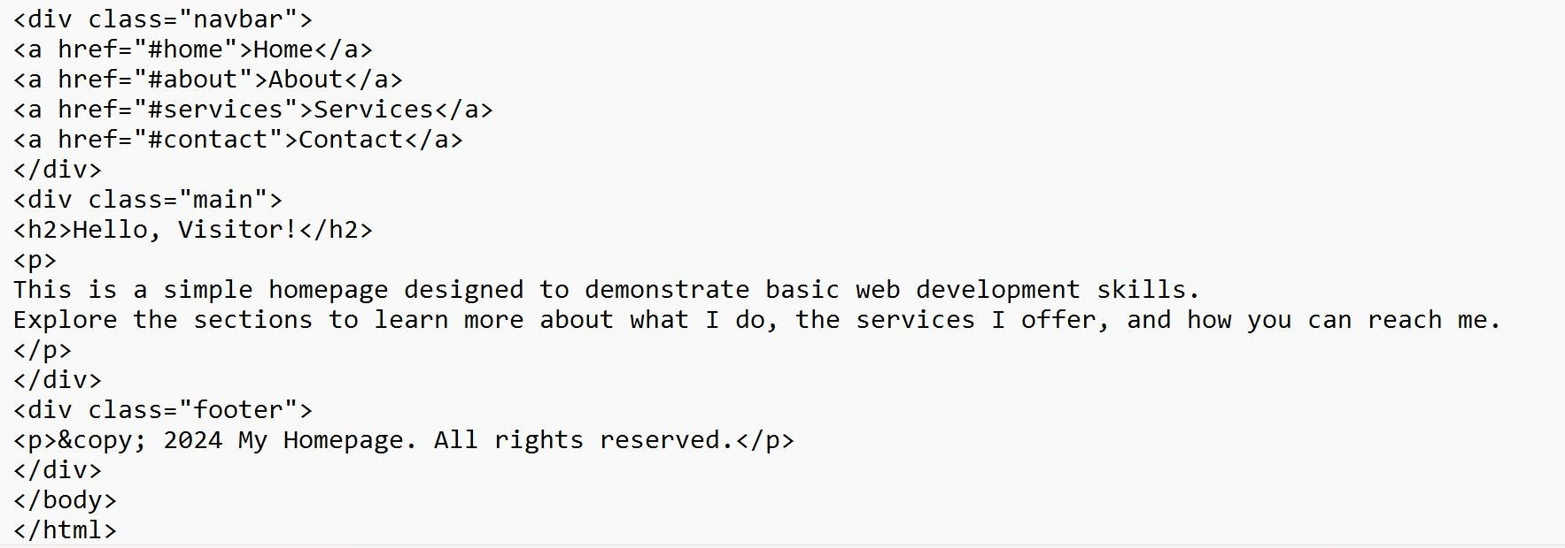

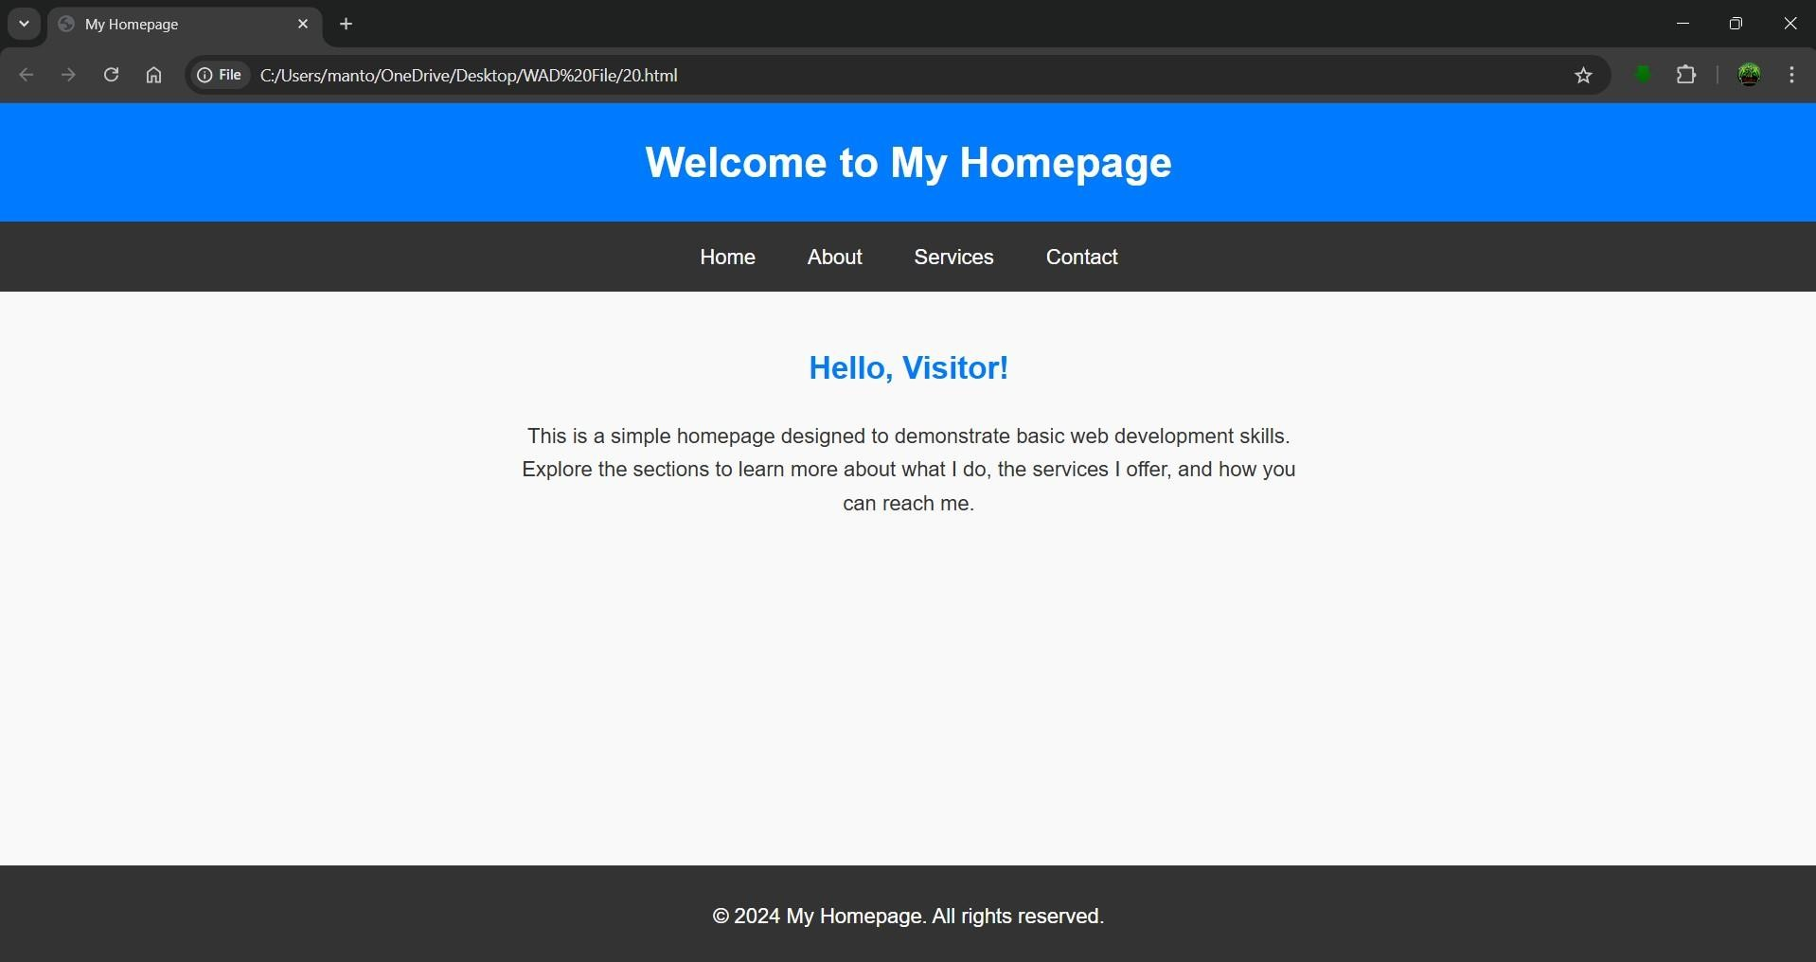

## Experiment No: 21

**Experiment 21:-** Write HTML code for including Local hyperlinking in a web page.

Student Name: deepak

Roll No: 23/SCA/BCA/078

Date of Performance: 25-10-2024

1. **Aim/Overview of the practical:**

To Create a HTML code for including Local hyperlinking in a web page.

1. **Result/Output/Writing Summary:**

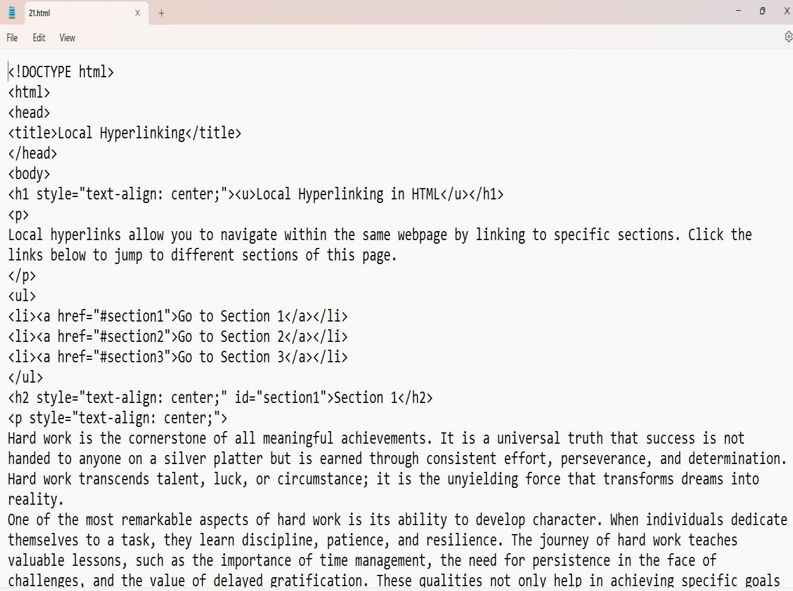

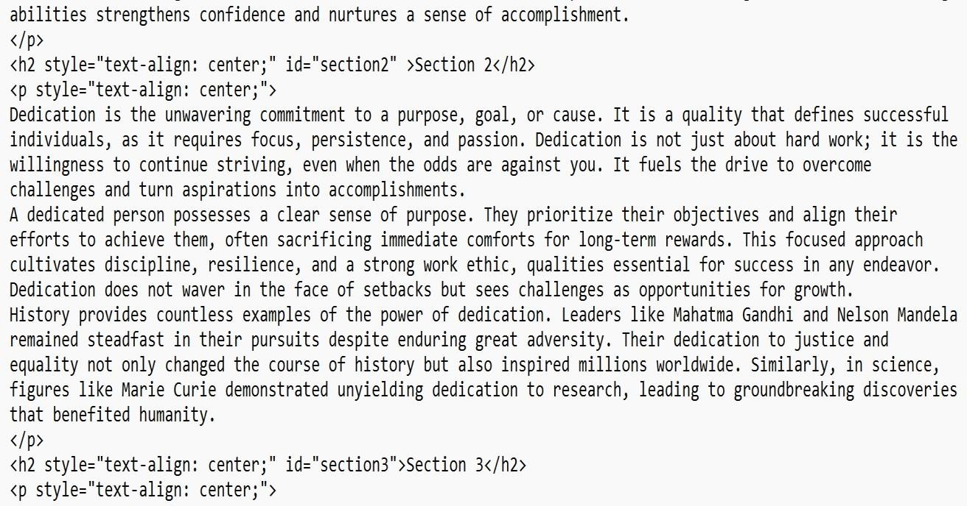

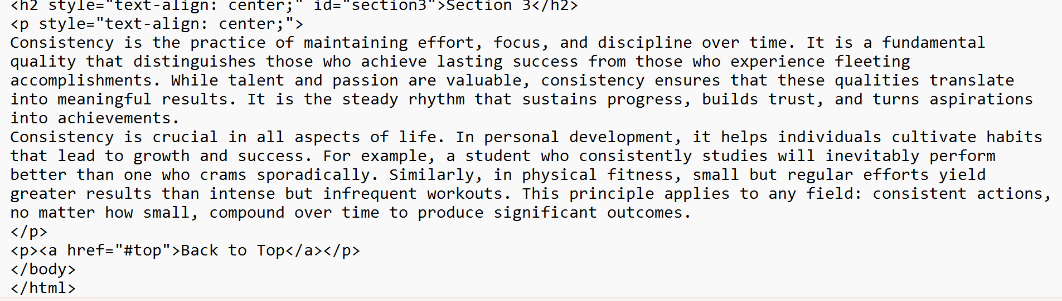

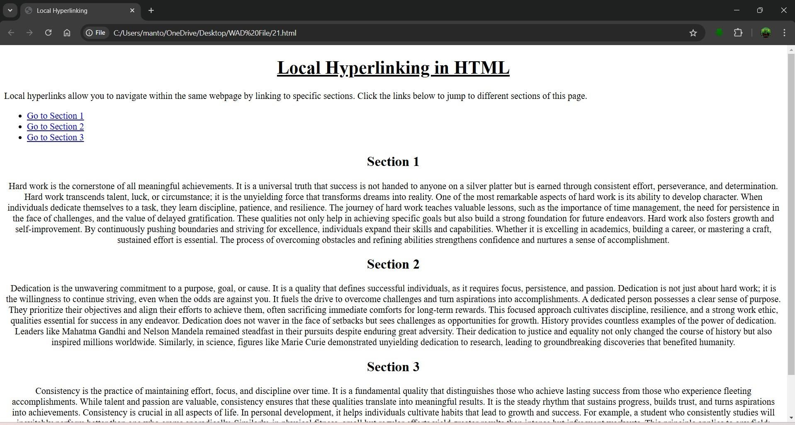

## EXPERIMENT:22

**Experiment 22:-** Write HTML code for including Inter hyperlinking in a web page. Student Name: deepak

Roll No: 23/SCA/BCA/078

Date of Performance: 25-10-2024

1. **Aim/Overview of the practical:**

To Create HTML code for including Inter hyperlinking in a web page.

1. **Result/Output/Writing Summary:**

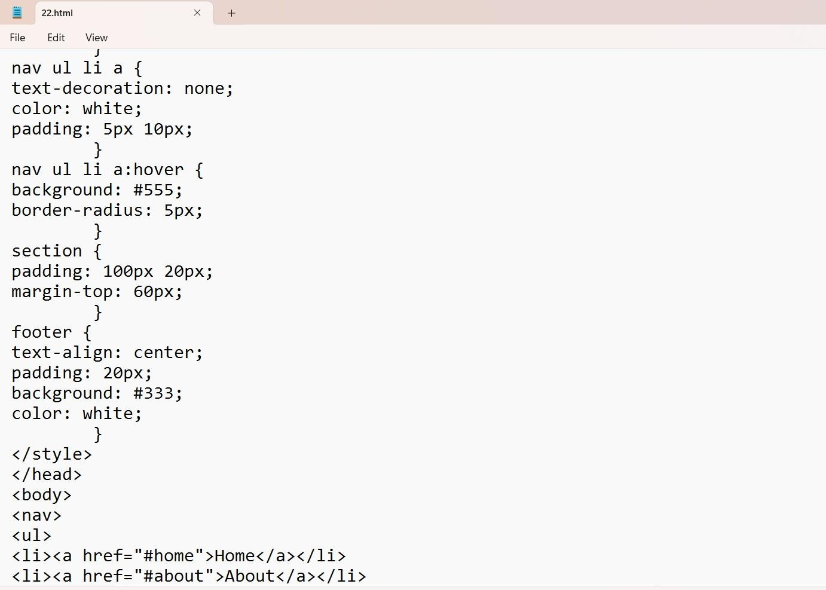

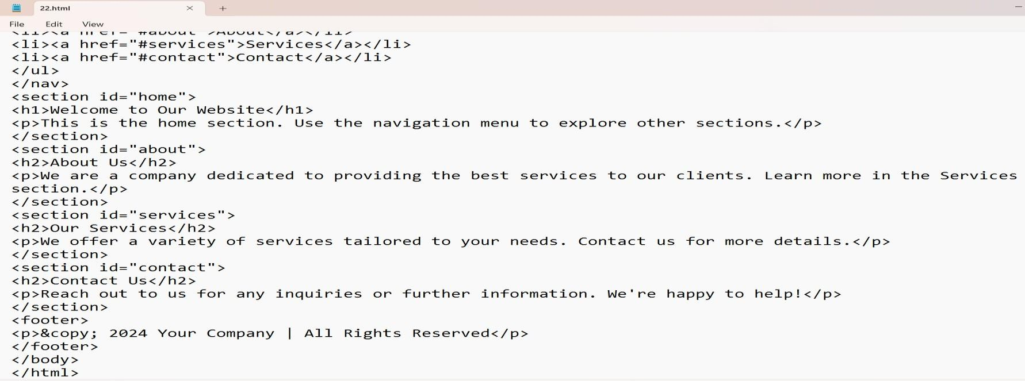

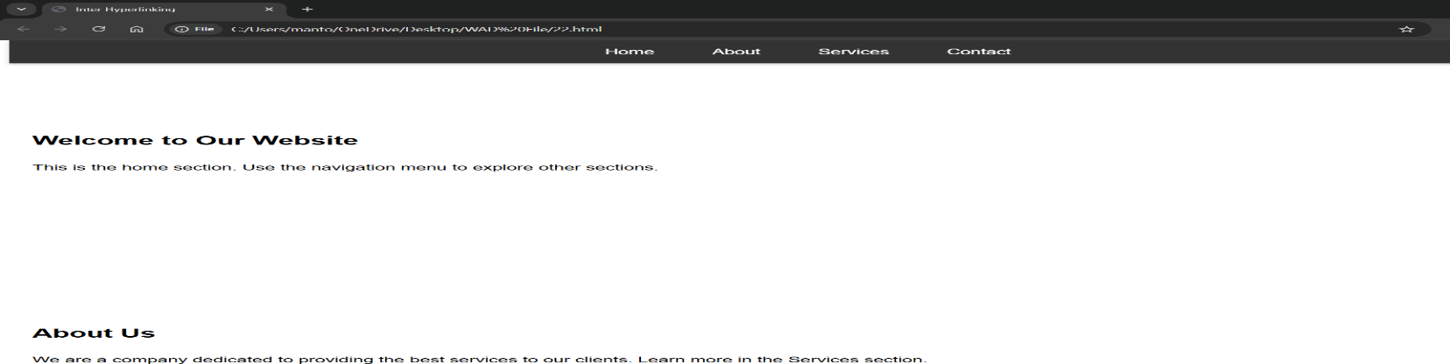



## Experiment:23

**Experiment 23:-** Write HTML code for including External hyperlinking in a web page.

Student Name: deepak

Roll No: 23/SCA/BCA/078

Date of Performance: 01-11-2024

1. **Aim/Overview of the practical:**

To Create HTML code for including External hyperlinking in a web page.

1. **Result/Output/Writing Summary:**

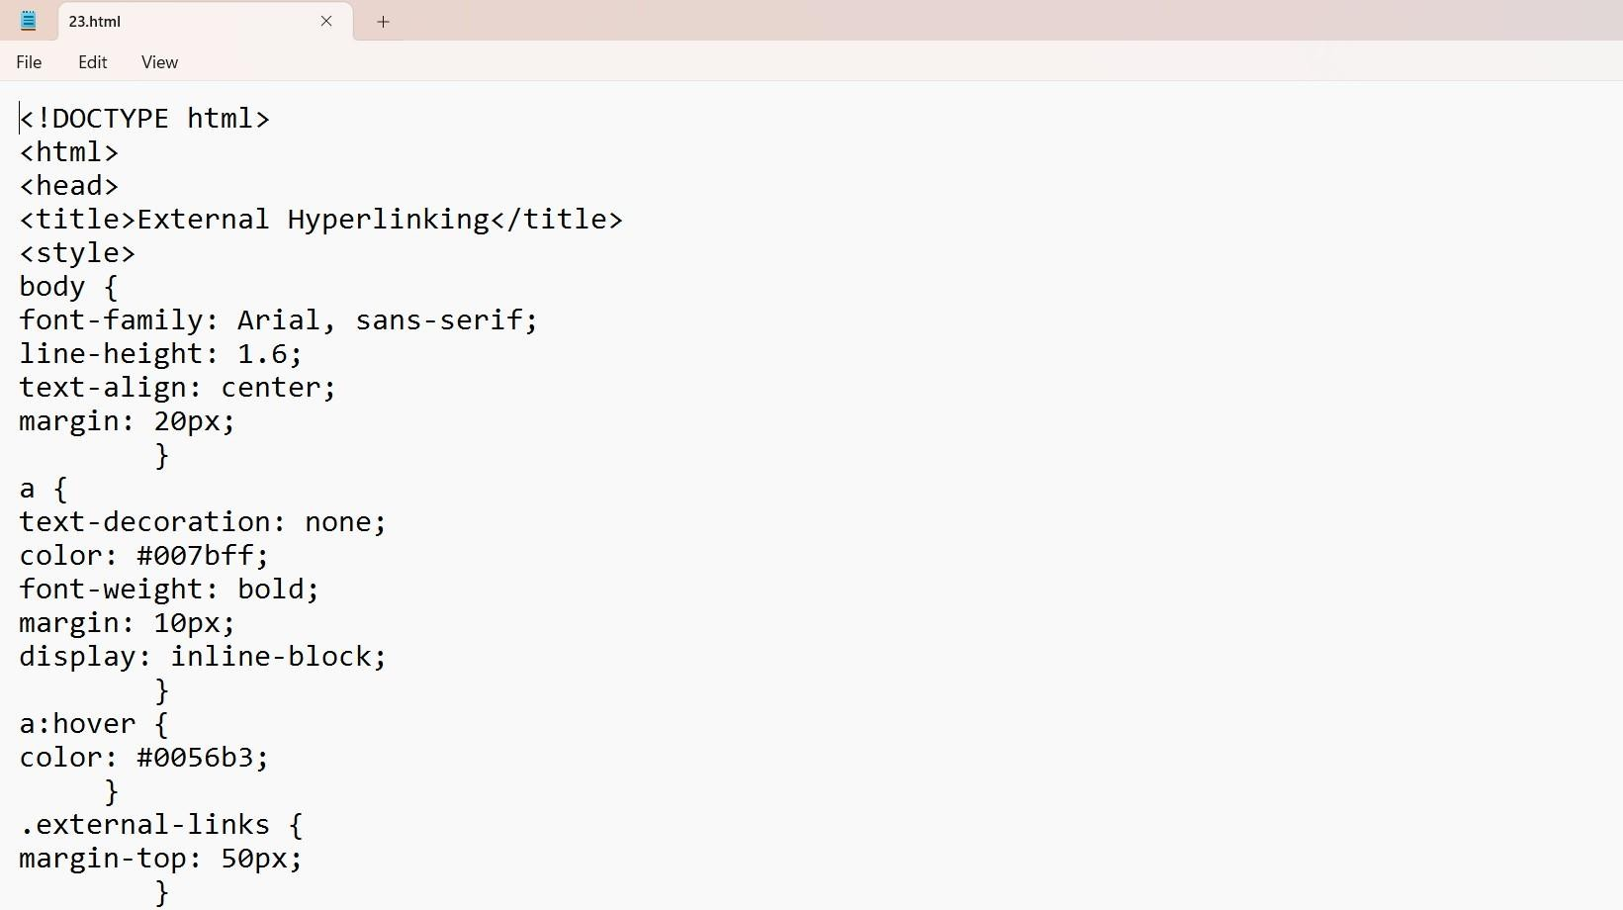

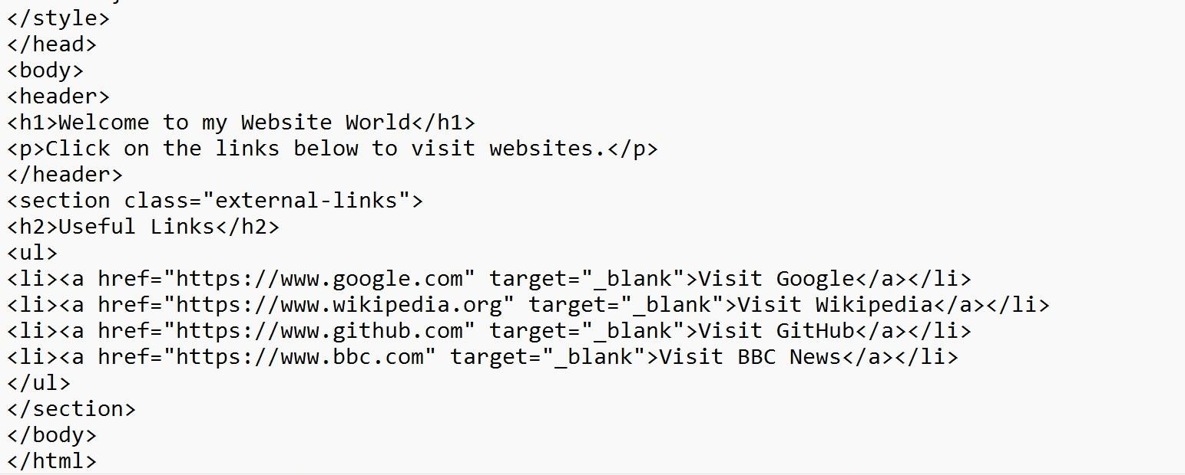

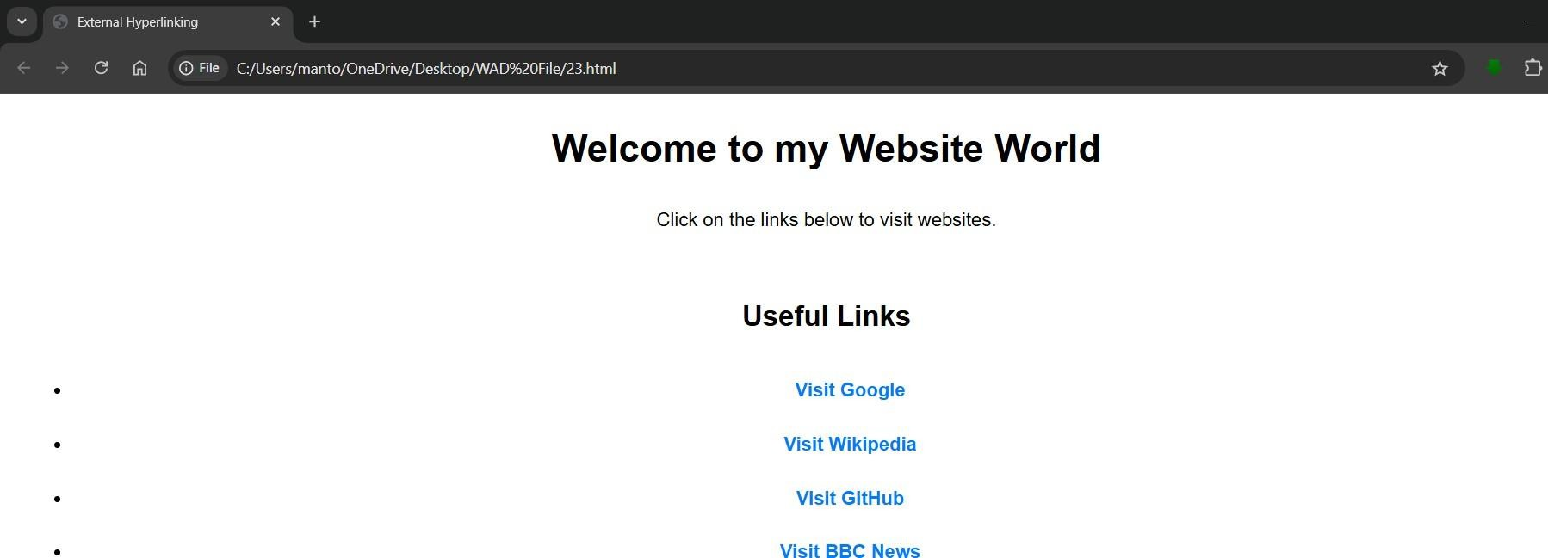

## Experiment:24

**Experiment 24:-** Write code to show External CSS with HTML code.

Student Name: deepak

Roll No: 23/SCA/BCA/078

Date of Performance: 01-11-2024

1. **Aim/Overview of the practical:**

To Create a code to show External CSS with HTML code.

1. **Result/Output/Writing Summary:**

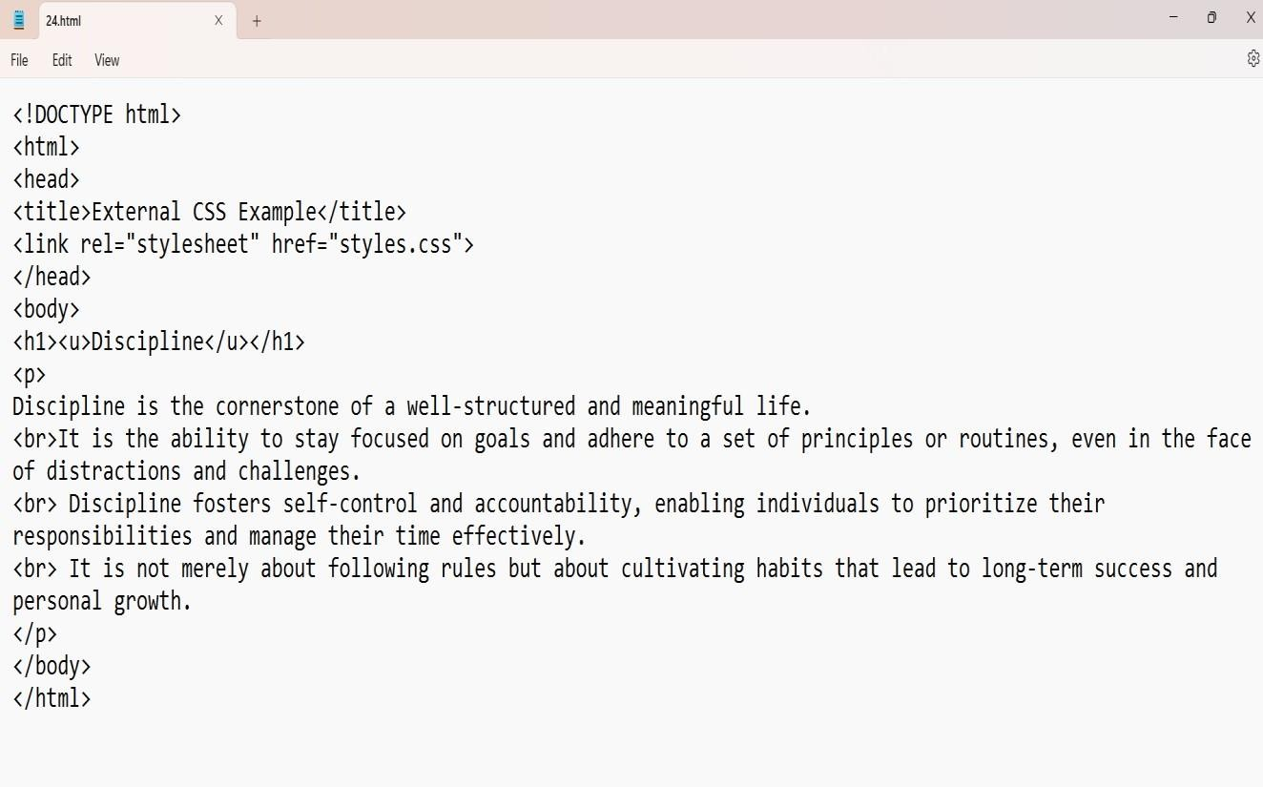

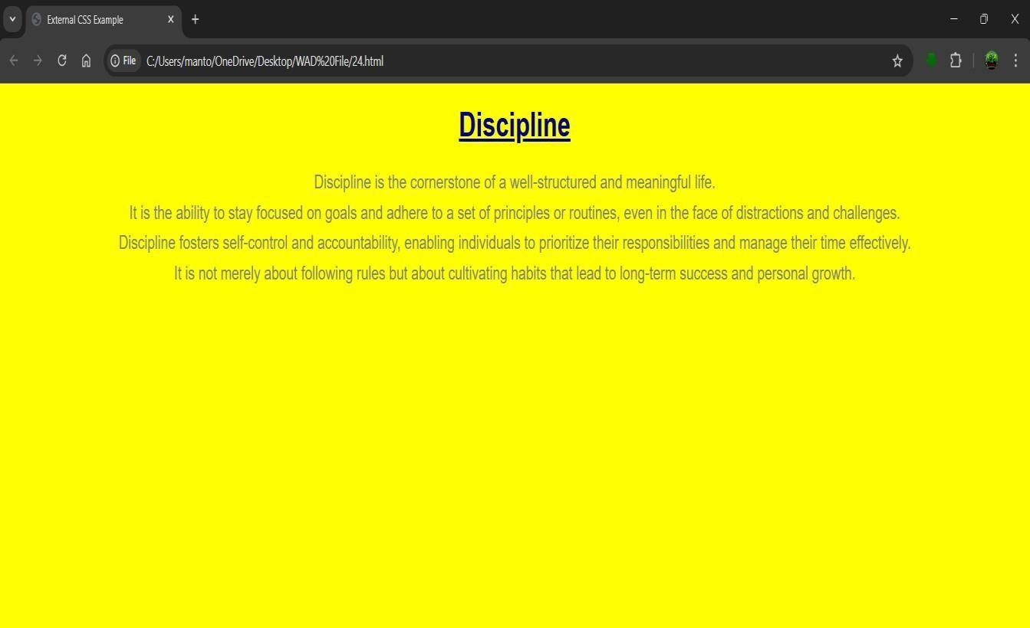

## Experiment No: 25

**Experiment 25:-** Write code to show Internal CSS with HTML code.

Student Name: deepak

Roll no: 23/SCA/BCA/078

Date of Performance: 01-11-2024

1. **Aim/Overview of the practical:**

To Create a code to show Internal CSS with HTML code.

1. **Result/Output/Writing Summary:**

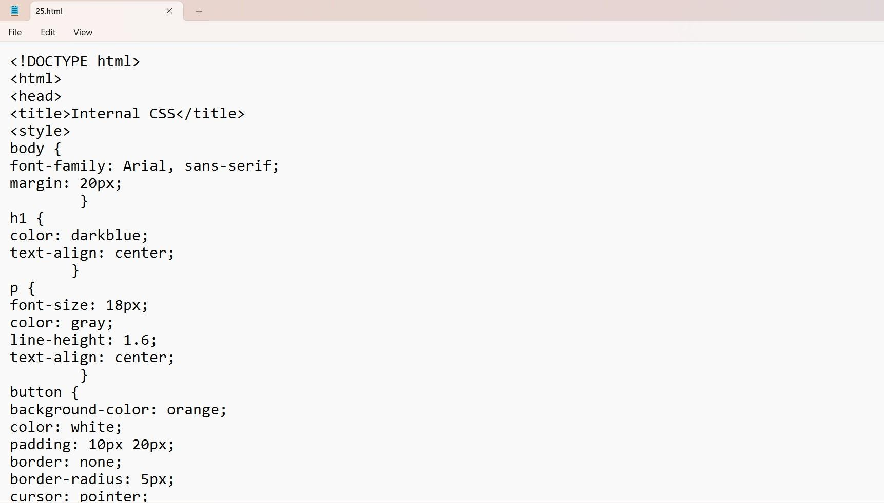

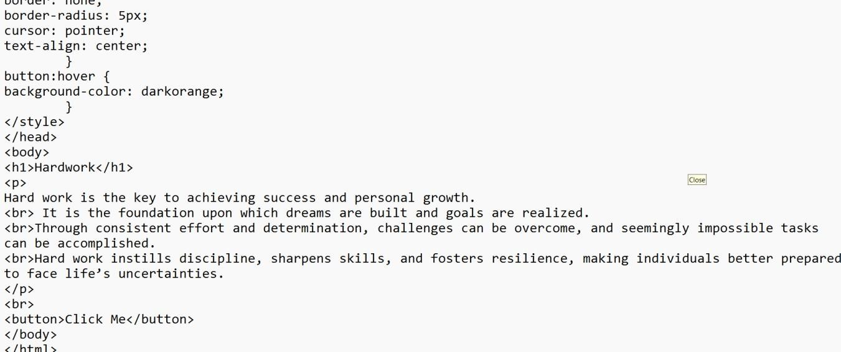

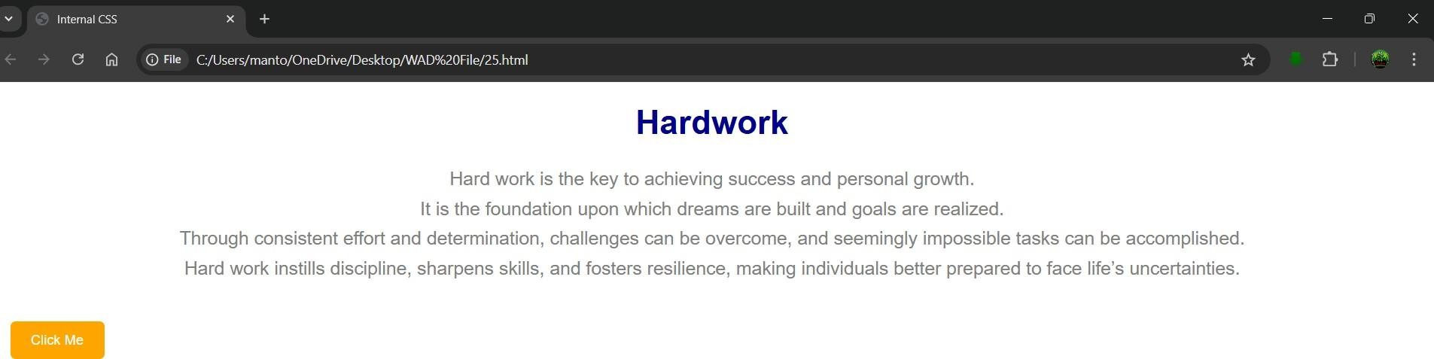

## Experiment No: 26

**Experiment 26:-** Write code to show Inline CSS with HTML code.

Student Name: deepak

Roll No: 23/SCA/BCA/078

Date of Performance: 08-11-2024

1. **Aim/Overview of the practical:**

To Create code to show Inline CSS with HTML code

1. **Result/Output/Writing Summary:**

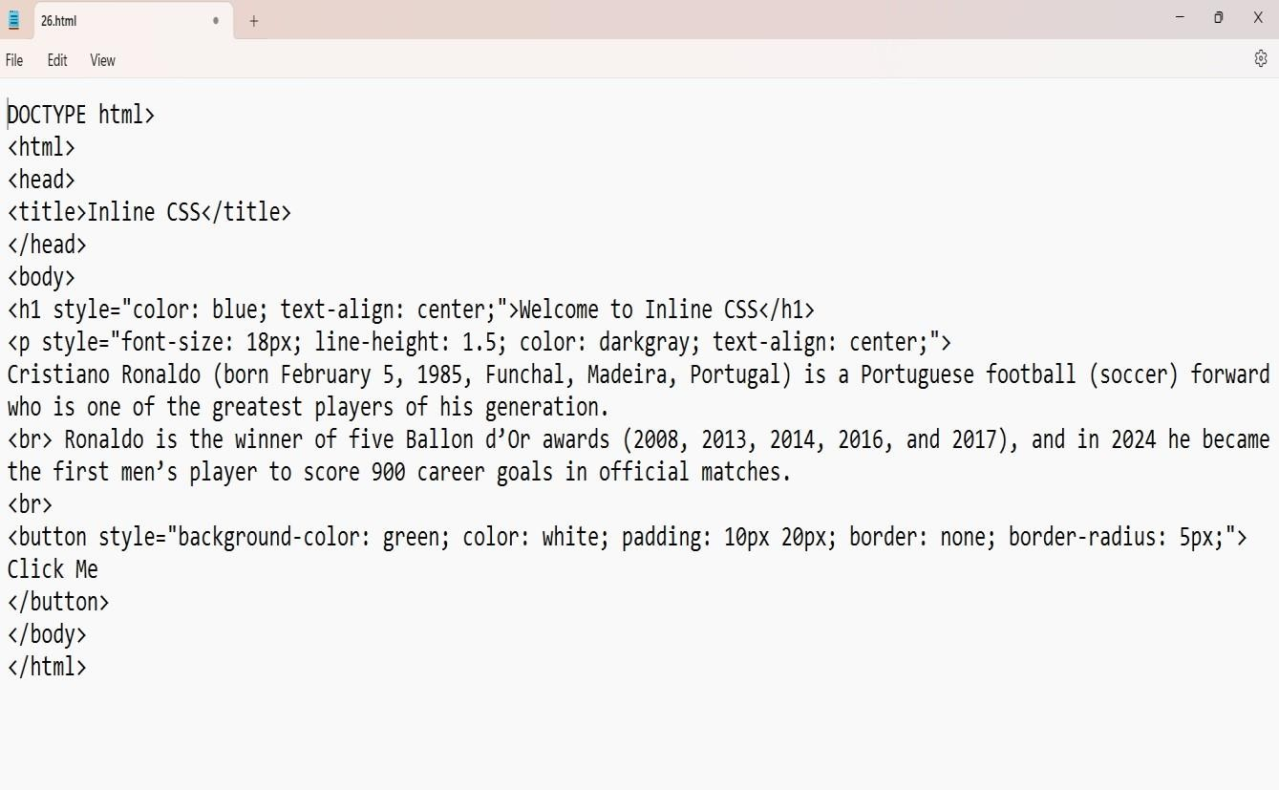

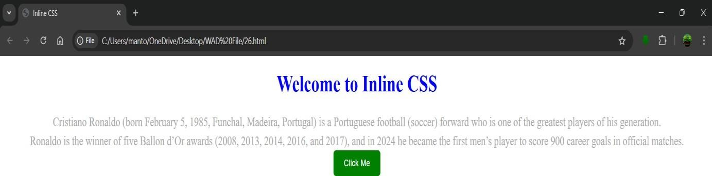

# Experiment No: 27

**Experiment 27** : **Write a program to add two numbers using form in Javascript.**

Student Name: deepak

Roll No: 23/SCA/BCA/078

Date of Performance: 27-09-2024

1. **Aim/Overview of the practical:**

Write a program to add two numbers using form in Javascript.

1. **Result/Output/Writing Summary:**

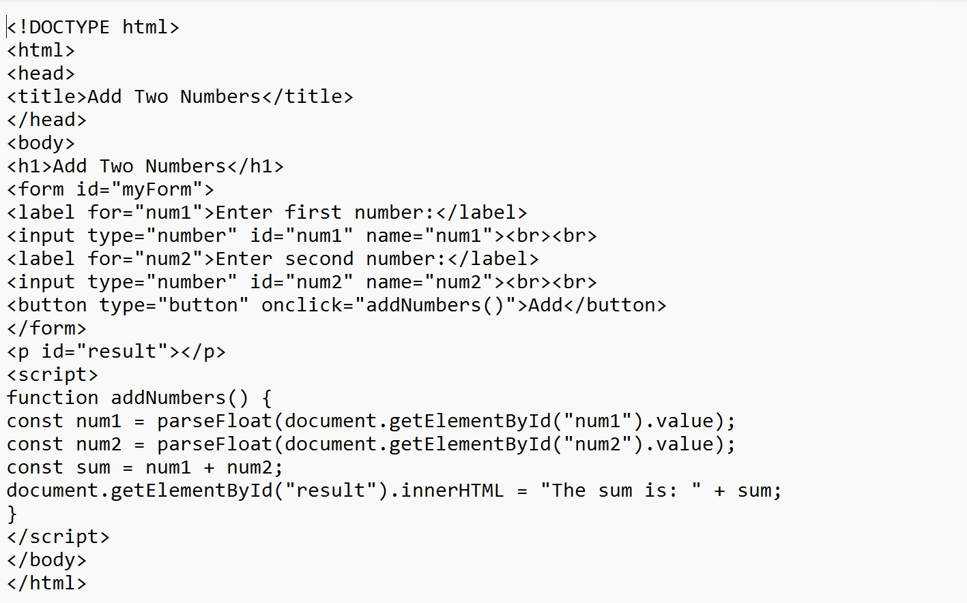

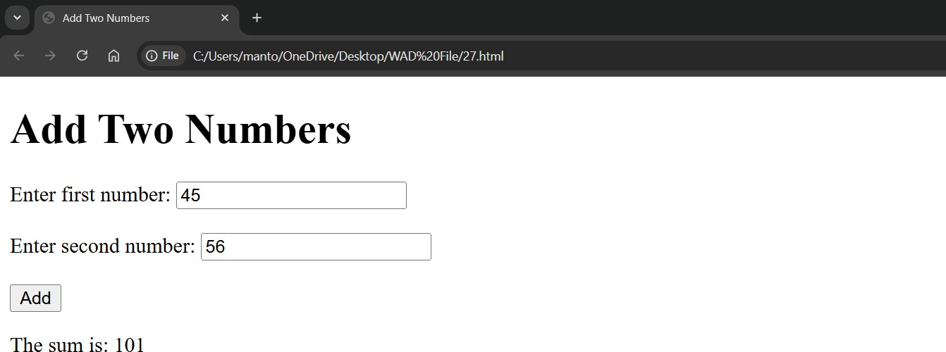

**EXPERIMENT:28**

**Experiment 28:-** Write a program in Javascript to swap two images using OnmouseOver event

Student Name: deepak

Roll No:23/SCA/BCA/078

Date of Performance: 04-10-2024

1. **Aim/Overview of the practical:**

To Create a program in Javascript to swap two images using OnmouseOver event

1. **Result/Output/Writing Summary:**

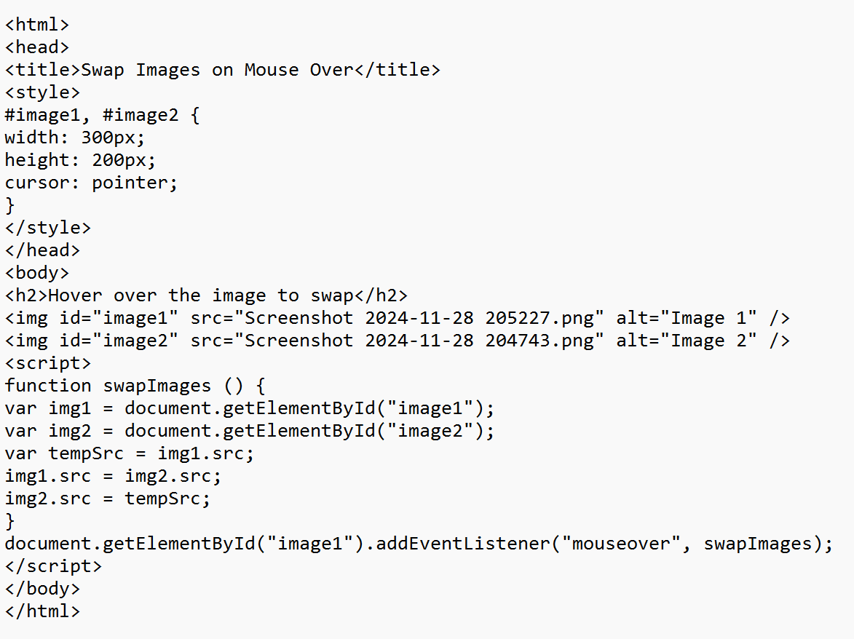





## Experiment:29

**Experiment 29:-** Write a simple JavaScript program to sort an array.

Student Name: deepak

Roll No:23/SCA/BCA/078

Date of Performance: 04-10-2024

1. **Aim/Overview of the practical:**

To Create a simple JavaScript program to sort an array.

1. **Result/Output/Writing Summary:**

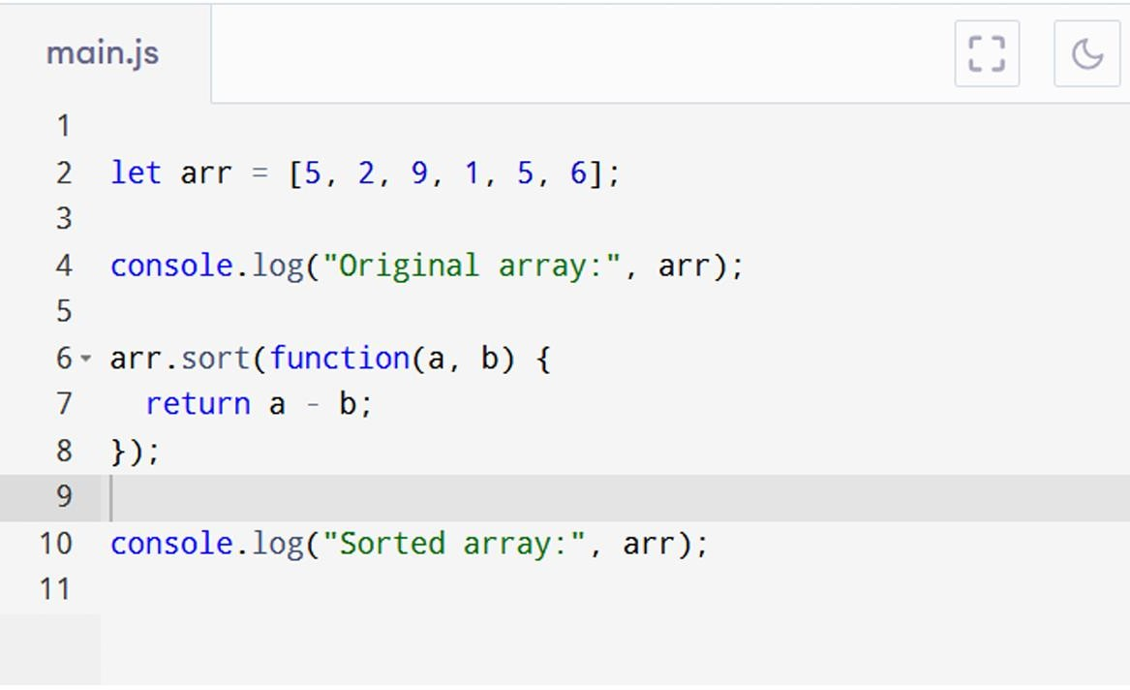

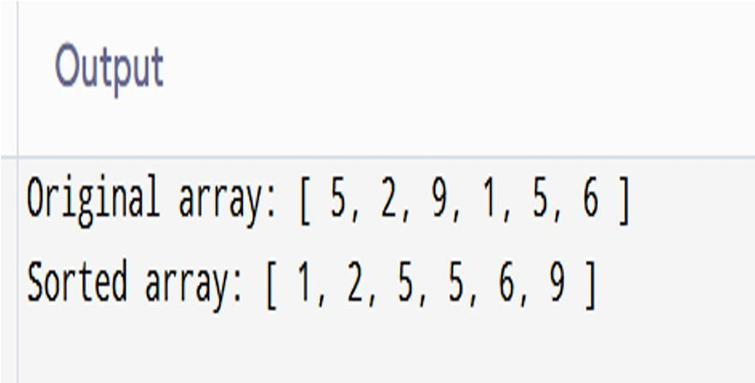

## Experiment:30

**Experiment 30:-** Write a JavaScript program to take as input three numbers from the user. Find the minimum and maximum of the three numbers. Print the following output in BOLD in the following format:

MINIMUM = MAXIMUM =

Student Name: deepak

Roll No:23/SCA/BCA/078

Date of Performance: 04-10-2024

1. **Aim/Overview of the practical:**

To Create a a JavaScript program to take as input three numbers from the user. Find the minimum and maximum of the three numbers. Print the following output in BOLD in the following format:

MINIMUM = MAXIMUM =

1. 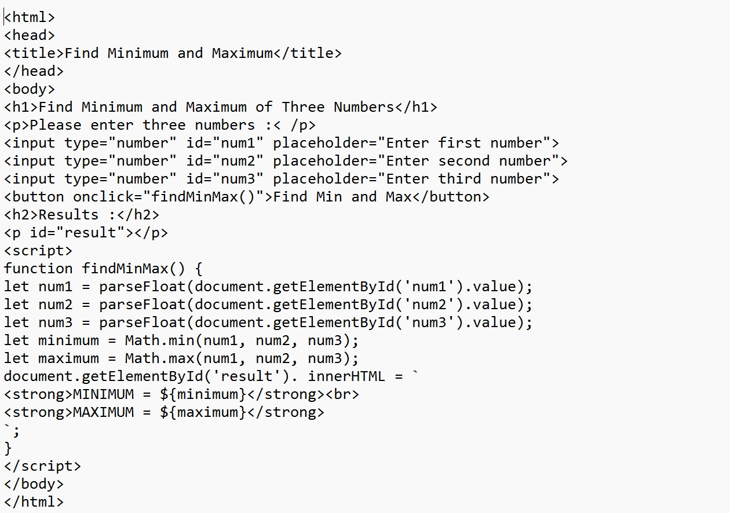**Result/Output/Writing Summary:**

